Marketing Plan for Rincon Surf Shack
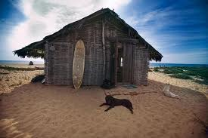

Report Submitted by County Line High School
1432 Padaro Lane
Santa Barbara, California
November 30, 20XX

Table of Contents
Industry Analysis | Page 3
Statistics | Page3
Trends | Page 4-5
Strengths | Page 6
Threats | Page 6
Target Market & Market Segmentation | Page 6-7
Product or Service | Page 8-19
Pricing Strategy | Page 20-23
Placement | Page 24-25
Promotion | Page 26-30

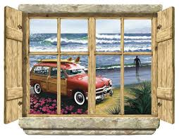

Industry analysis
The surfing market has steadily grown since its inception in the late 50’s early 60s. There are approximately 1, 736,000 American surfers and about 23 million worldwide. The surfboard has undergone major changes as well. The average weight of the originally designed surfboard was 100 pounds. Today it is around 11 pounds. The weight and also depends on the type of board and its length.
Annual surfing revenue totals 12 billion dollars. Surfboards skateboard and accessories make up only $1.56 billion. Foot ware, mostly attributable to sandals, totals $1.6 billion each year. Wet suits make up a small fraction of the total posting $119 million yearly sales. The accessory part of the industry is led by the sale of sunglasses. Annual apparel wear is the biggest part of the industry totaling approximately $8 billion of the $12 billion total sales.

SIMA - Surf Industry Manufacturers Association announced that the industry grew from $6.2 billion in 2004 to $7.48 billion in 2006, a 14% increase. The increase is due to a number of factors: mainstream popularity of the surf life style, the capitalization of the purchasing power of women, and brand diversification. Another reason for growth is that surfboard makers distribute their products through surf and skate shops, not big box retailers.
Another part of analyzing the statistics of your industry, involves seeing how many surf shops are there in Virtual Enterprise Network. These are your main competitors. Looking at last year’s Virtual Enterprise companies, there was only one other board shop and they did not sell and clothing. We plan to sell board shorts, hoodies, T-shirts, and sandals in addition to surfboards.
Industry Analysis - Trends in Surf Industry
The industry has changed significantly since the inception of the Southern California culture. Surfer was mainly teenagers in the 1960's. They followed a beach lifestyle. Their clothes consisted of baggies or board shorts as they are called today. The bikini was popular with the girls who admired the surfers. They were called beach bunnies. Very few women surfed in the early 60’s. Today’s top surfers earn millions of dollars in surf competitions and product endorsements.
Surf music was born with groups like Dick Dale and The Deltones. They played instrumental surfing music. The Beach boys group was formed. Jan and Dean sang songs about surfing and skateboarding. Surfing Safari, Surf City, Surfer Girl, Wipe Out.

Skateboards became popular with surfers since they became a way to surf on land and become part of the surfing culture. Retailers have more brand choices but are carrying fewer brands and product categories. While only 23% of core retailers use Internet/Catalog sales, those who use it have seen a 29.5% increase in sales. Overall shoe sales are down, but sandals sales are up to over $300 million - an increase of over $50 million since 2004. Apparel is the largest product category with an increase of 9.9% in sales in 2006 and currently has sales over $8 billion. Men's board shorts have continued to see strong growth. Wetsuits represent a small percent of core sales, dollars are up 30% due to price points.
The major players in the surfing industry include: Billabong, Body Glove, Channel Islands Surfboards, O'Neill, Quicksilver, Rip Curl. Accessories: sunglasses, watches, bags, hats, saw slight sales growth of 4.3%. Most of the increase was due to sunglasses. Hard goods: surfboards, skateboards, snowboards, wake boards, sales are up 24% from 2004 to 2006. There are more female surfers now and surfers are getting older. Females make up 36% of the surfing population. The median income of a surfer is $75,000 per year. Artificial waves created at a wave break park could have a significant positive influence on the surfing market.
The growing popularity of long boards has made the industry grow. It is easier to learn how to surf on a long board. Surfboards have changed drastically since the 1960’s. In the early years long boards were the only choice. They ranged in length for 9’ 2” to 10’ 6” and weigh about 40-45 pounds. There are now other choices that are much lighter, faster, smaller and more maneuverable. Short boards range in length from 6’ 2” to 7’ 2”. There are designs for both beginners and intermediate users. There are also other designs and shapes available including stand up paddle boards.
SIMA - Surf Industry Manufacturers Association and others have increased visibility through promotional and educational programs.

Industry Analysis - Strengths
Surfing has gone from a 60's cult sport to the mainstream with bona-fide stars, major surfing competitions. The surfer look is an important style for America's youth. By 2017 the surfing market will make 13.24 billion dollars. Surfing is a health and fitness sport that can be done at any age. Great cardiovascular benefits can be attributed to surfing. Surfing strengthens core strength in back shoulders and legs and it is a great way to spend time outdoors. Surfing reduces stress and tension.
Industry Analysis - Threats
Surfing can be addicting and make you think of only one thing – surfing. You may want to miss work, quality time with friends. It can be dangerous: skin cancer, ear infections, and damaged hair. Injuries can be serious.
Some big apparel surf brands: Billabong, Quicksilver, Pac Sun have recorded large financial losses recently. Some of the loss can be attributed to the economic turn down. Today's surfers don't want to wear the same clothes that their fathers wore.
Target Market and Market Segmentation
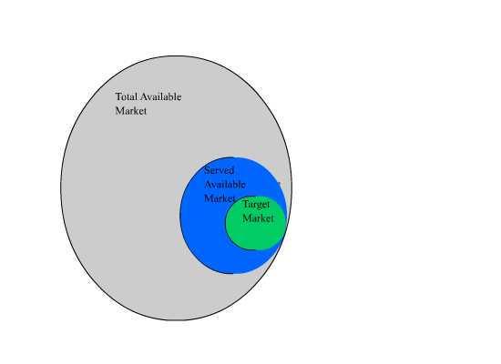
The shaded gray area represents the total market consisting of all buyers. The blue circle represents the available customers in the Sporting Goods/Sporting Apparel Market. The green circle represents the target market for our company.
The target market for Rincon Surf Shack is
- 14- 23 age demographic
- Generation I or Generation Z: the Internet generation- very technology oriented
- Education: Junior High School, High School Students, College Students
- Entrepreneurial / Virtual Enterprise students
- Income is derived from their virtual pay for their Virtual Enterprise job that ranges from $45,000 - $100,000 per year.
- Both Male and Female
- Interested in the surf lifestyle: clothing, accessories and surfboards.
- Marital Status: Single
- Ethnicity: All races
- Mode of transportation: Car, bus, bike, walk, skateboard
- Leisure activities: outdoor activities

Market Segmentation by Age
- The surfing market is composed of a number of segments:
- The old timers, those that surfed in the 60's- the baby boomers
- Generation X - those born between 1965 and 1975
- Generation y - About 70 million, no exact date, but after Generation X. Fastest growing segment of the work force.
- Generation I or Generation Z - The Internet generation 1990 - present
Market Segmentation of Surfboard by size
- Short boards
- Long Boards
- Stand Up Boards
Market Segmentation by Category
- Hard Goods: surfboards, skateboards, snowboards, wake boards
- Accessories: sunglasses, watches, bags, hats, belts
- Apparel: Surf and Skate and Beach Clothing
- Footwear: Sandals
- Wet suits
- Product
Our product line is composed of a number of elements. We plan to carry surfboards, short, long and stand up. In addition we will carry a full line of surf wear including baggies or board shorts for men and women, sandals, T-shirts, and hoodies.

- Short Boards
We chose Channel Islands Surfboards as our supplier as they are local and have an excellent reputation for shaping top-quality surfboards. We will carry three models in varying sizes: The Weirdo Ripper, The DFR and the New Flyer. The tables below summaries these items in our product line.

Product Picture | Product Name | Product Description
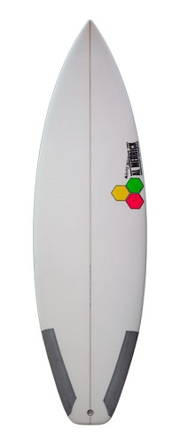 | The New Flyer  Length Width Thickness Volume  5'6" 18 1/4" 2 1/16" 21.7 L  5'8" 18 3/8" 2 1/8" 23.2 L  5'9" 18 1/2" 2 3/16" 24.3 L  5'10" 18 5/8" 2 1/4" 25.6 L  5'11" 18 7/8" 2 5/16" 27.0 L  6'0" 19" 2 3/9" 28.3 L  6'1" 1 1/8" 2 7/16" 29.6 L  6'2" 19 1/4" 2 1/2" 31.0 L  6'3" 19 1/2" 2 9/16" 32.6 L  6'4" 19 3/4" 2 5/8" 34.2 L  6'5" 19 7/8" 2 11/16" 35.7 L  6'6" 20" 2 3/4" 37.2 L  6'8" 20 1/4" 2 3/4" 38.7 L  6'10" 20 1/2" 2 7/8" 41.9 L | This board is built for high performance in small waves. It is shorter and wider. The plan-shape allows for the same volume in a shorter rail line. Two stage rockers, spiral Vee starting in front of one of the fins to allow for rail to rail quickness. It is now available with a unidirectional carbon strip which stiffens the middle of the board giving it a tighter turn radius.
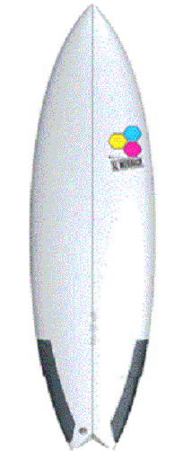 | The Weirdo Ripper  Length Width Thickness Volume  5'6" 18 1/4" 2 1/16" 21.7 L  5'8" 18 3/8" 2 1/8" 23.2 L  5'9" 18 1/2" 2 3/16" 24.3 L  5'10" 18 5/8" 2 1/4" 25.6 L  5'11" 18 7/8" 2 5/16" 27.0 L  6'0" 19" 2 3/9" 28.3 L  6'1" 1 1/8" 2 7/16" 29.6 L  6'2" 19 1/4" 2 1/2" 31.0 L  6'3" 19 1/2" 2 9/16" 32.6 L  6'4" 19 3/4" 2 5/8" 34.2 L  6'5" 19 7/8" 2 11/16" 35.7 L  6'6" 20" 2 3/4" 37.2 L  6'8" 20 1/4" 2 3/4" 38.7 L  6'10" 20 1/2" 2 7/8" 41.9 L | The Weirdo Ripper is meant for medium to waves slightly overhead. Its shape is that of a medium all-around board. Full volume, easy to paddle, wide point forward, V bottom, square winged bottom tail. Length of board should match your height.
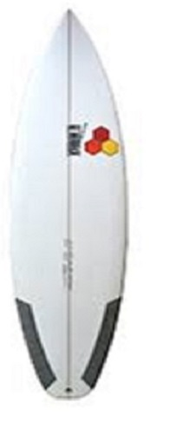 | The DFR  Length Width Thickness Volume  5'6" 18 1/4" 2 1/16" 21.7 L  5'8" 18 3/8" 2 1/8" 23.2 L  5'9" 18 1/2" 2 3/16" 24.3 L  5'10" 18 5/8" 2 1/4" 25.6 L  5'11" 18 7/8" 2 5/16" 27.0 L  6'0" 19" 2 3/9" 28.3 L  6'1" 1 1/8" 2 7/16" 29.6 L  6'2" 19 1/4" 2 1/2" 31.0 L  6'3" 19 1/2" 2 9/16" 32.6 L  6'4" 19 3/4" 2 5/8" 34.2 L  6'5" 19 7/8" 2 11/16" 35.7 L  6'6" 20" 2 3/4" 37.2 L  6'8" 20 1/4" 2 3/4" 38.7 L  6'10" 20 1/2" 2 7/8" 41.9 L | The DFR is an ultra-modern short board, the plan-shape allows for a short rail line while maintaining drive. The bottom is predominately single concave and features an aggressive flip in exit rail rocker. A full outline provides enough volume to ride the DFR about the same length as your height.

- Long Boards and Stand Up Paddle Boards
To appeal to the older surfers and beginners we carry two long board models and one stand up paddle board. Long boards were the staple of the 60’s generation surfers and many of them still prefer to ride a long board. Long boards are much better in really big surf. Due to the size of the board, it is easier for beginners to acquire the skill of surfing. The table below shows this part of our product line.

Product Picture | Product Name | Product Description
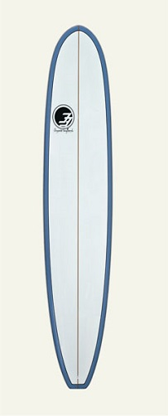 | Performance  Length Width Thickness  8”0” 22” 2.75”  8’6” 22.5” 2.75”  9’0” 22.75” 2.95”  9’6” 23” 3.0”  10’0” 23.5” 3.35”  10”2” 24” 3.50” | This board is built for beginners to advanced surfers. Our Performance long boards are designed for all around wave riding with the responsiveness you need in a variety of wave conditions. You can purchase it in classic glass, NexGen epoxy or standard epoxy.
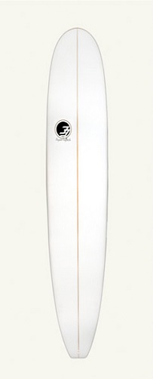 | Nose Rider  Length Width Thickness  8”0” 22” 2.75”  8’6” 22.5” 2.75”  9’0” 22.75” 2.95”  9’6” 23” 3.0”  10’0” 23.5” 3.35”  10”2” 24” 3.50” | The Nose Rider is designed with the older surfer and beginner in mind. Older surfers will remember when hanging ten was really special. The wider and longer board allows you to take those steps to walk the board and hang ten, and walk back to stall and slow the board. The Nose Rider comes in a large variety of heights, widths and thickness to provide the perfect fit for all kinds of surfers young or old. Whether you are a beginner or an older surfer this board is for you.
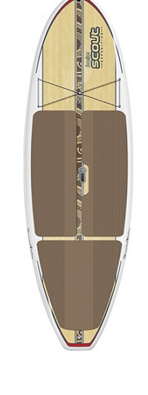 | Stand Up Paddle Board  Weight Length Width  120-150 lbs 10’6” 28-30”  160-190 lbs 11’0” 29-32”  200-230 lbs 11’0”-11’6” 29-32”  240-270 11”6”-12’ 32-33”  280+ 12”0” 33” | Stand up paddling (SUP) has been practiced since the inception of surfing in Hawaii. Surf instructors have often used the stand up position to keep an on eye on their clients. Paddleboards come in a variety of lengths, widths, thicknesses and construction

- Men’s Board Shorts
Our men’s board shorts are from Quicksilver and Billabong Manufacturing companies. They are reminiscent of the baggie shorts worn by surfers of the 1960’s. They are made of top-quality materials and are made to last while surfing or just walking on the beach. They all feature colorful designs are a great addition to any man’s wardrobe. The table below shows the product line carried by Rincon Surf Shack.

Product: Men’s Board Shorts | Description
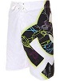The Surfer Shorts | These nylon board shorts are designed for the active surfer. Their bold stripes go well with any style board.  Sizes: small, medium, large, XL and XXL  Catalog # mbs1
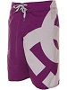Shoot the Curl | These handsome shorts were the creation of a top surfer. They have a special pocket for your wax.  Sizes: small, medium, large, XL and XXL  Catalog # mbs2
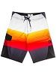The Hawaiian Tornado | These shorts with their bold polka-A Dots are a favorite on the beaches of Southern California  Sizes: small, medium, large, XL and XXL  Catalog # mbs3
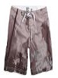The Baggie Shorts | These nylon board shorts are designed for the active surfer. Their bold stripes go well with any style board.  Sizes: small, medium, large, XL and XXL  Catalog # mbs4
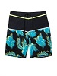The Surfer Safari Shorts | These handsome shorts were the creation of a top surfer. They have a special pocket for your wax.  Sizes: small, medium, large, XL and XXL  Catalog # mbs5
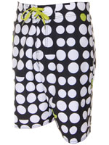The Manhattan Beach Special | These shorts with their bold polka-A Dots are a favorite on the beaches of Southern California.  Sizes: small, medium, large, XL and XXL  Catalog # mbs6

- Women’s Board Shorts
Our women’s board shorts are from Quicksilver and Billabong Manufacturing companies. They are created for the women of style. They are made of top-quality material and are made to last while surfing or just walking on the beach. They all feature colorful designs are a great addition to any woman’s s wardrobe. The table below shows the product line carried by Rincon Surf Shack.
Product: Women’s Board Shorts | Description
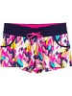 | Multi-colored with a black waist band  Sizes: XS, small, small, medium, large, XL  Catalog # wbs1
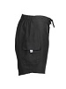 | Solid black long fitted leg  Sizes: XS, small, small, medium, large, XL  Catalog # wbs2
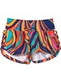 | Orange, blues and red shorts  Sizes: XS, small, small, medium, large, XL  Catalog # wbs4
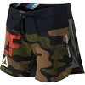 | Camouflage shorts  Sizes: XS, small, small, medium, large, XL  Catalog # wbs4
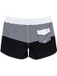 | Sizes: XS, small, small, medium, large, XL  Catalog # wbs5
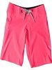 | Hot pink medium length leg shorts  Sizes: XS, small, small, medium, large, XL  Catalog # wbs6

- Men’s Sandals
Our men’s sandals are made of top-quality material and designed to fit the active person. They come in sizes 7-14. The brands we carry from Decker’s, Dockers and Birkenstock
Product: Men’s Sandals | Description
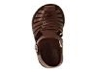The Fisherman | These inexpensive sandals are good for all around summer comfort.  Sizes: 7, 8, 9, 10, 11, 12, 13, 14  Catalog # ms1
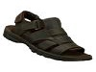Sketchers | These good-looking sandals are made of durable rubber outsole.  Sizes: 7, 8, 9, 10, 11, 12, 13, 14  Catalog # ms1
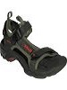Teva | These high quality shoes are blend of the best parts of shoes and sandals.  Sizes: 7, 8, 9, 10, 11, 12, 13, 14  Catalog # ms3
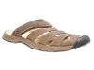Baja | Traditional nylon webbing makes this shoe a winner.  Sizes: 7, 8, 9,10, 11, 12, 13, 14  Catalog # ms4
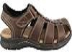Dockers Marin | These sandals were inspired by the wine country of California.  Sizes: 7, 8, 9, 10, 11, 12, 13, 14  Catalog # ms5
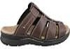Dockers Slide | These sandals are easy to get into an out of in a hurry  Sizes: 7, 8, 9, 10,11, 12, 13, 14  Catalog # ms6

- Women’s Sandals
Our line of women’s sandals is very fashionable and will go with any outfit from swim suits to dresses. They are made of top-quality materials. We carry sizes 4-11.
Product: Women’s Sandals | Description
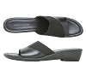 | These inexpensive sandals are good for all around summer comfort.  Sizes: 4, 5, 6, 7, 8, 9, 10, 11  Catalog # ws1
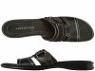 | These good-looking sandals are made of durable rubber out sole.  Sizes: 4, 5, 6, 7, 8, 9, 10, 11  Catalog # ws2
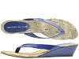 | These high quality sandals are made for comfort and durability.  Sizes: 4, 5, 6, 7, 8, 9, 10, 11  Catalog # ws3
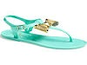 | Traditional jell webbing make this shoe a winner.  Sizes: 4, 5, 6, 7, 8, 9, 10, 11  Catalog # ws4
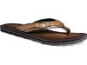 | These sandals were inspired by the</p><p> surfers in California.  Sizes: 4, 5, 6, 7, 8, 9, 10, 11  Catalog # ws5
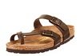 | These high quality leather sandals are designed for comfort and long walks.  Sizes: 4, 5, 6, 7, 8, 9, 10, 11  Catalog # ws6

- T-Shirts
Our T-shirts are made from 100% cotton. We feature designers like Billabong, Quicksilver and Hang-Ten. We guarantee that they will not shrink. Our sizes range from extra small to double extra Large. They come in a multitude of colorful designs. Billabong supplies us with all of our t-shirts.
Product: T-Shirts | Description
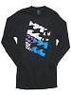Tropics | These Tropic T-Shirts are fashionable and made to last. Coordinate Them with our board shorts.  Sizes: X small, small, medium, large, XL, and XXL  Catalog # ts1
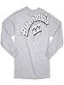Voyage | This good-looking T shirt is made of all 100 cotton and features our signature Billabong Logo.  Sizes: Xs small, small, medium, large, XL<, An XXL  Catalog # ts2
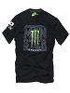Hawaiian | These T's make you feel that you are in the Hawaiian Islands  Sizes: X small, small, medium, large, XL, and XXL  Catalog # ts3
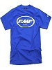Hammond’s Reef | The shirt won't fade or shrink. Looks like new every time you wear it.  Sizes: x small, small, medium, large, XL, and XXL  Catalog # ts4
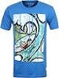Trade Winds | This colorful Tee features a surfer locked inside a wave.  Sizes: x small, small, medium, large, XL, XXL  Catalog # ts5

Hoodies
Stay nice and warm in our wide-selections of hoodies. Throw one on after a long day of surfing in the winter. Sizes range from extra small for the petite surfer girl to double extra large for the large muscular guy.
Product: Hoodies | Description
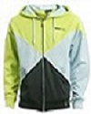Tropics | These hoodies are fashionable and made to last. Coordinate with our board shorts.  Sizes: X small, small, medium, large, XL, and XXL  Catalog # h1
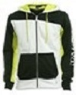Basic Black | This good-looking hoodie is made of all 100 cotton and comes in yellow with black accents.  Sizes: Xs small, small, medium, large, XL<, An XXL  Catalog # h2
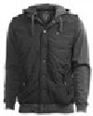Hammond’s Reef | These hoodies make you look slim and fit  Sizes: X small, small, medium, large, XL, and XXL  Catalog # h3
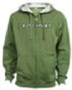Trade Winds | The hoodie won't fade or shrink. Looks like new every time you wear it.  Sizes: x small, small, medium, large, XL, and XXL  Catalog # ts4
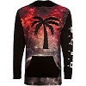Manhattan Beach | This colorful number features a palm tree</p><p>with a sunset background.  Sizes: x small, small, medium, large, XL, XXL  Catalog # h5
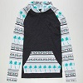 | This hoodie is designed especially for the California surfer girl.  Sizes: X small, small, medium, large, XL, and XXL  Catalog # h6

Price List for Rincon Surf Shack

Rincon Surf Shack Price List for Short Boards
Name of Product | Length | Cost | Retail Price
New Flyer | 5'6" | $338.90 | $648.00
New Flyer | 5'9" | $341.26 | $652.50
New Flyer | 5'10" | $349.10 | $667.50
New Flyer | 6'0" | $353.03 | $675.00
New Flyer | 6'2" | $358.52 | $685.50
New Flyer | 6'4" | $363.22 | $694.50
DFR | 5'6" | $355.64 | $680.00
DFR | 5'9" | $355.64 | $680.00
DFR | 5'10" | $363.49 | $695.00
DFR | 6'0" | $363.49 | $695.00
DFR | 6'2" | $363.49 | $695.00
DFR | 6'4" | $368.72 | $705.00
Weirdo Ripper | 5'6" | $338.90 | $648.00
Weirdo Ripper | 5'9" | $341.26 | $652.50
Weirdo Ripper | 5'10" | $349.10 | $667.50
Weirdo Ripper | 6'0" | $353.03 | $675.00
Weirdo Ripper | 6'2" | $358.82 | $685.00
Weirdo Ripper | 6'4" | $363.22 | $694.50

Rincon Surf Shack Price List for Long Board/Fiberglass
Name of Product | Length | Cost | Retail Price
Performance | 8'0" | $450.00 | $675.00
Performance | 8'6" | $455.00 | $682.50
Performance | 9'0" | $467.00 | $700.50
Performance | 9'6" | $476.00 | $714.00
Performance | 10'0" | $514.00 | $771.00
Performance | 6'4" | $363.22 | $694.50
Nose Rider | 8'0" | $450.00 | $675.00
Nose Rider | 8'6" | $455.00 | $682.500
Nose Rider | 9'0" | $467.00 | $700.50
Nose Rider | 9'6" | $476.00 | $714.00
Nose Rider | 10'0" | $514.00 | $771.00

Rincon Surf Shack Price List for Long Board/NextGenEpoxy
Name of Product | Length | Cost | Retail Price
Performance | 8'0" | $330.00 | $495.00
Performance | 8'6" | $300.00 | $450.00
Performance | 9'0" | $356.00 | $534.00
Performance | 9'6" | $376.00 | $564.00
Performance | 10'0" | $344.00 | $516.00
Nose Rider | 8'0" | $330.00 | $495.00
Nose Rider | 8'6" | $300.00 | $450.500
Nose Rider | 9'0" | $356.00 | $534.00
Nose Rider | 9'6" | $376.00 | $564.00
Nose Rider | 10'0" | $344.00 | $516.00

Rincon Surf Shack Price List for Stand Up Paddle Board
Name of Product | Length | Cost | Retail Price
SUP | 12'0" | $523.00 | $1,000.00
SUP | 13'0" | $523.00 | $1,000.00
SUP | 14'0" | $627.60 | $1,200.00

Rincon Surf Shack Price List for Men's Board Shorts
Catalog num | Cost | Retail Price
mbs1 | $36.35 | $69.50
mbs2 | $36.35 | $69.50
mbs3 | $25.89 | $49.50
mbs4 | $24.05 | $45.99
mbs5 | $39.23 | $75.00
mbs6 | $39.23 | $75.00

Rincon Surf Shack Price List for Women's Board Shorts
Catalog # | Cost | Retail Price
wbs1 | $29.26 | $55.95
wbs2 | $29.26 | $55.95
wbs3 | $25.89 | $49.50
wbs4 | $20.89 | $39.95
wbs5 | $39.23 | $75.00
wbs6 | $44.46 | $85.00

Rincon Surf Shack Price List for T-Shirts
Catalog # | Cost | Retail Price
ts1 | $18.30 | $34.99
ts2 | $14.64 | $27.99
ts3 | $17.78 | $33.99
ts4 | $13.07 | $24.99
ts5 | $14.62 | $27.95
ts6 | $17.78 | $33.99

Rincon Surf Shack Price List for Men's Sandals
Catalog # | Cost | Retail Price
ms1 | $15.17 | $29.00
ms2 | $47.07 | $90.00
ms3 | $18.28 | $34.95
ms4 | $47.07 | $90.00
ms5 | $23.51 | $44.95
ms6 | $23.51 | $44.95

Rincon Surf Shack Price List for Women's Sandals
Catalog # | Cost | Retail Price
ms1 | $15.17 | $29.00
ms2 | $18.30 | $34.99
ms3 | $10.45 | $19.99
ms4 | $11.50 | $21.99
ms5 | $9.93 | $18.99
ms6 | $47.06 | $89.99

Rincon Surf Shack Price List for Hoodies
Catalog # | Cost | Retail Price
ms1 | $52.50 | $100.00
ms2 | $44.46 | $85.00
ms3 | $73.21 | $139.99
ms4 | $34.00 | $65.00
ms5 | $65.38 | $125.00
ms6 | $78.45 | $150.00

Placement

Our channels of distribution are as follows:
We buy our short boards from Channel Islands Surfboards at the cost price shown above.
The boards are shipped directly from Channel Islands facility to the end consumer.
Orders come for our Internet Web Page.
We use United Parcel Service and Federal Express to ship the boards as well as all of our other merchandise.
Degree 33 is our supplier for Long boards and stand up paddle boards. The items are billed to us at the cost seen above and the boards are shipped directly for their facility via UPS and Fed EX.
Billabong and Quicksilver manufacture our board shorts, T-shirts and hoodies. The cost price listed above is what we pay and the merchandise is shipped directly from their facility to our customers using public carriers,
Our sandals come from Decker’s Outdoor Corporation and Dockers. The same billing and shipping arrangements are identical to those described above.
We set up a booth at all the California Trade shows where we sell to VE students and adult visitors.
Our classroom is also a place where we sell our product line. We have monthly open houses and a grand opening.
Our web page is the main vehicle for selling our products.
1. The home page features our logo of the Rincon Surf Shack and a horizontal menu to access all of the other pages.
2. The URL is http://RinconSurfShack.com. It has been registered and our meta tags titles and keywords have been submitted to all the major search engines: Google, Bing, Internet Explorer, Firefox, and Ask.
3. Our URL has been submitted to the VEC office to be included in the shopping mall.
4. There is a page that shows our organizational chart and explained each employees' job titles and descriptions.
5. There is a Contact Us page that has linked to our officers' email accounts, the classroom phone number and our school's address.
6. It has a products page which features our product line including pictures, descriptions and prices.
7. It has a shopping cart page built in and the orders are directed to our marketing and accounting department emails.
8. Included in the web site is a page where shoppers can drag and drop clothing items onto a manikin to see how different outfits go together.

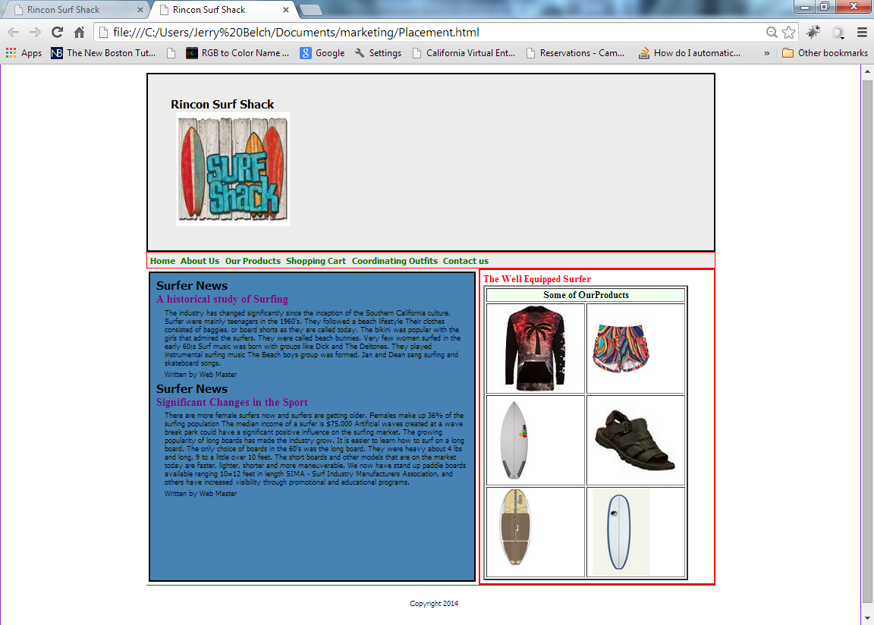

Promotion

The main vehicle used to promote our surf shack is our web page

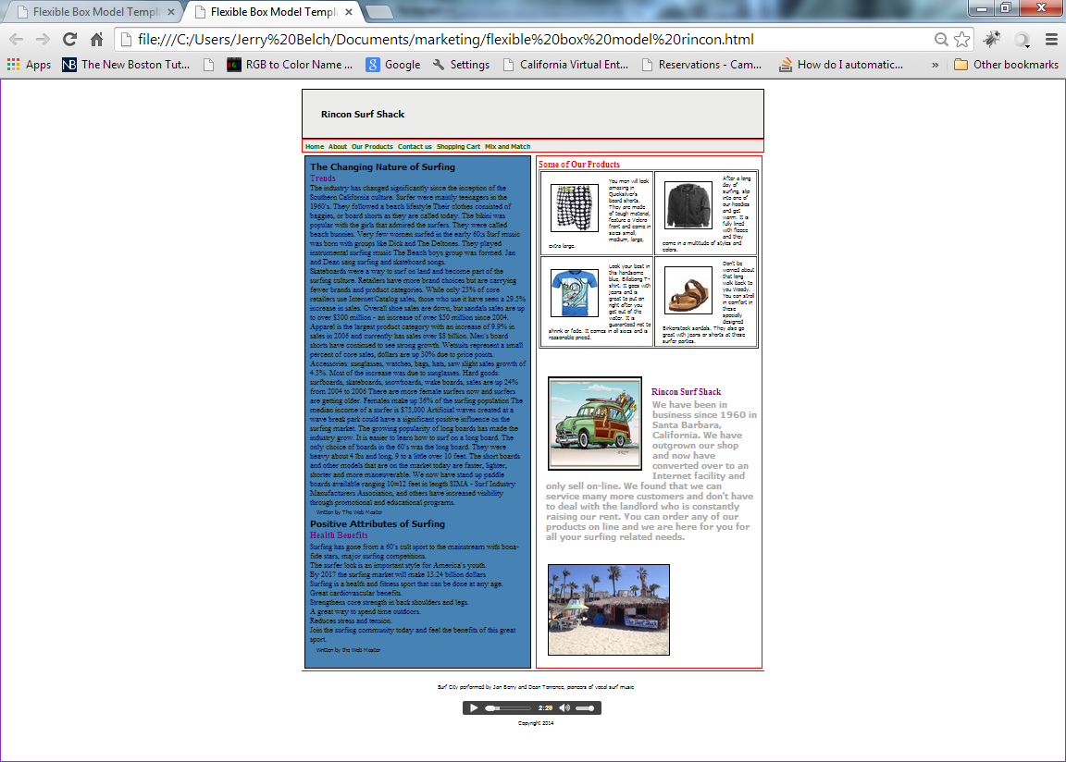
Our web page was coded in HTML 5 and represents the flexible box model of programming. HTML 5 makes it much easier to adapt web pages to other devices including cell phones and tablets.
It features two articles: one on the changing nature of surfing and the other on the health benefits of surfing. The right side of the screen id devoted to some of our product line including board shorts, T-shirts, hoodies and sandals. A picture of a vintage woody is shown along with our logo, which is a surf shack. The footer contains an audio player and allows the used to listen to Surf City, a number one hit on July 1963 by Jan Berry and Dean Torrance. The song was co-written by Jan Berry and Brian Wilson of Beach Boys fame.
Internet Advertisement
We designed and Internet ad to be included as an attachment to all Virtual Companies. I was coded in HTML 5 so that it can be viewed by cell phones, tablets as well as regular computers.
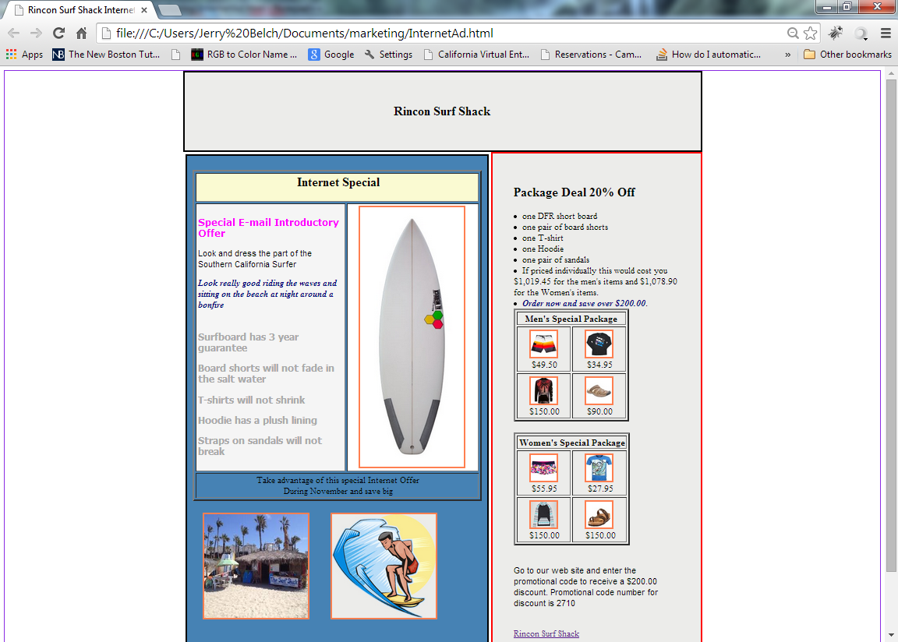
The ad offers a package deal on a surfboard, board shorts, a T-shirt, hoodie and sandals. There is a package for men and one for women. If they enter the correct promotional code on our web site they will receive 20% off of regular price.

Rincon Surf Shack
Booth 22
Trade Show Special – 25% off on these items
Billabong Tropics T-shirt $34.99 | Women’s Camouflage Board Shorts  $39.99 | Dockers Marin Men’s Sandals  $44.95
Tropics Hoodie  $100.00 | Men’s Surfer Safari Shorts  $75.00 | Hawaiian T-Shirt  $33.99

DFR short board 5’6” - $680.00
Our flyer that will be used to promote our booth appears above and it features a 25% discount on the selected products.

We plan to hold a drawing for a T-shirt during each trade show.

We plan to attend all of the California Trade Shows where our sales department can promote our products.

We will have a grand opening in January, where we will invite school personnel, city dignitaries. We plan to obtain TV coverage of the event and have a write up in our local newspaper.

