Information Technology
Annual Report
June 1,20XX
Web Page
Our web page was created using a template from WixIt. It had a home page, a company page, the dating survey page and a shopping cart where student could choose between our three dating packages. It was hosted on our school site and linked to our school’s web page, We competed in the web design competition in Bakersfield and won third place in the intermediate division.
We also created a video commercial, which we entered into competition and won honorable mention
Dating Survey Matches
A large amount of our time this past year was spent on compiling the dating files received from our online survey and running them through our computer dating software to find matches, and profiles for our clients.
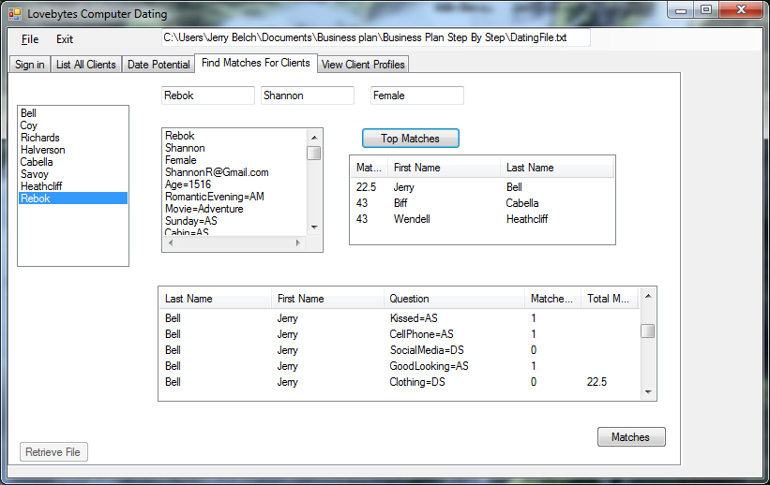

Date Potential
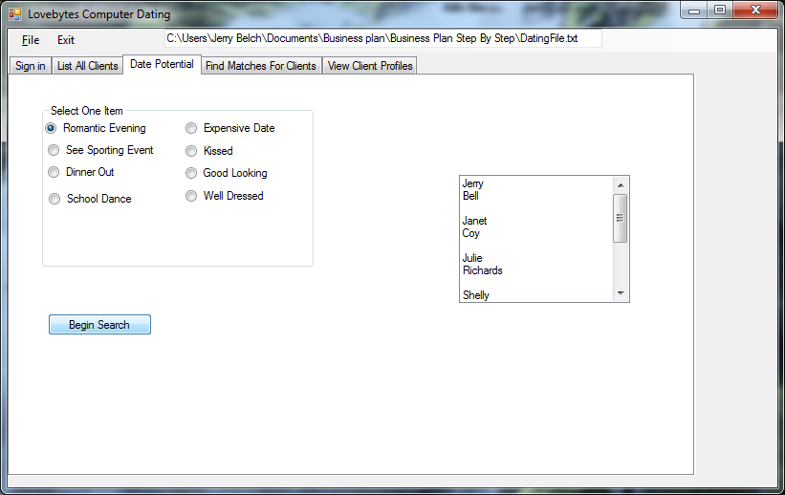

Dating Profiles
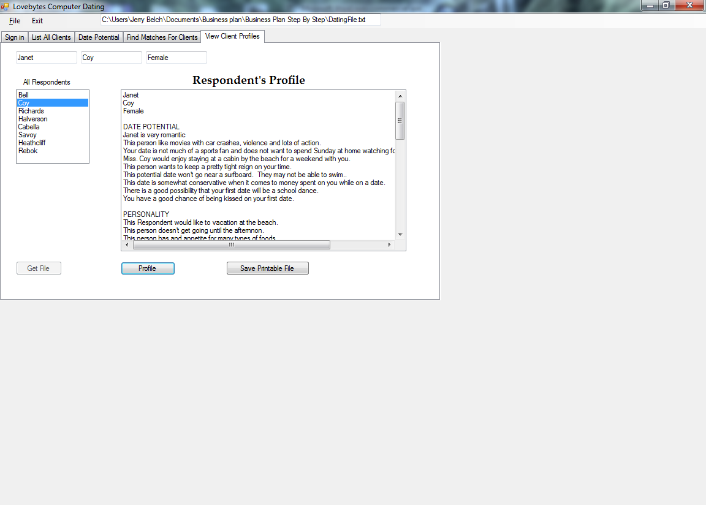
Internet Advertising
Our department also created e-mail type advertisements for our dating service
Putting it all together.
It was our department’s responsibility to put this entire report together.

