Rincon Surf Shack
Booth 22
Trade Show Special – 25% off on these items
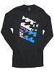  Billabong Tropics T-shirt $34.99 | 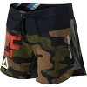  Women’s Camouflage Board Shorts  $39.99 | 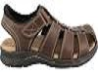  Dockers Marin Men’s Sandals  $44.95
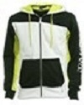  Tropics Hoodie  $100.00 | 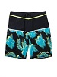  Men’s Surfer Safari Shorts  $75.00 | 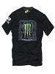  Hawaiian T-Shirt  $33.99

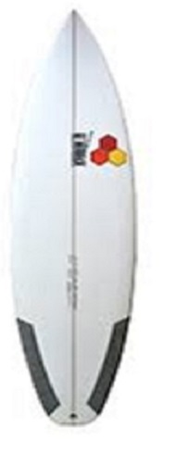DFR short board 5’6” - $680.00

