Virtual Enterprise Payroll Simulation



________________________________________________________________________

Written by Jerry Belch
November 2005

Virtual Enterprise Payroll Simulation

Lesson Overview
Exercise 1: Loading program and Setup of company information
Exercise 2: Files set up and creating employee records
Exercise 3: Totaling time cards for the month of July
Exercise 4: Entering the hours worked
Exercise 5: Viewing/Printing the payroll register
Exercise 6; Posting payroll totals to employee earning records
Exercise 7: Printing the paychecks
Exercise 8: Payroll taxes report
Exercise 9: August’s Payroll
Exercise 10: After the simulation/Your own company

Exercise 1: Loading the program and setting up the Company Information File
To load the program
- Click on Start
- Click on Programs
- Click on Payroll
Your Screen should look like the one pictured below.
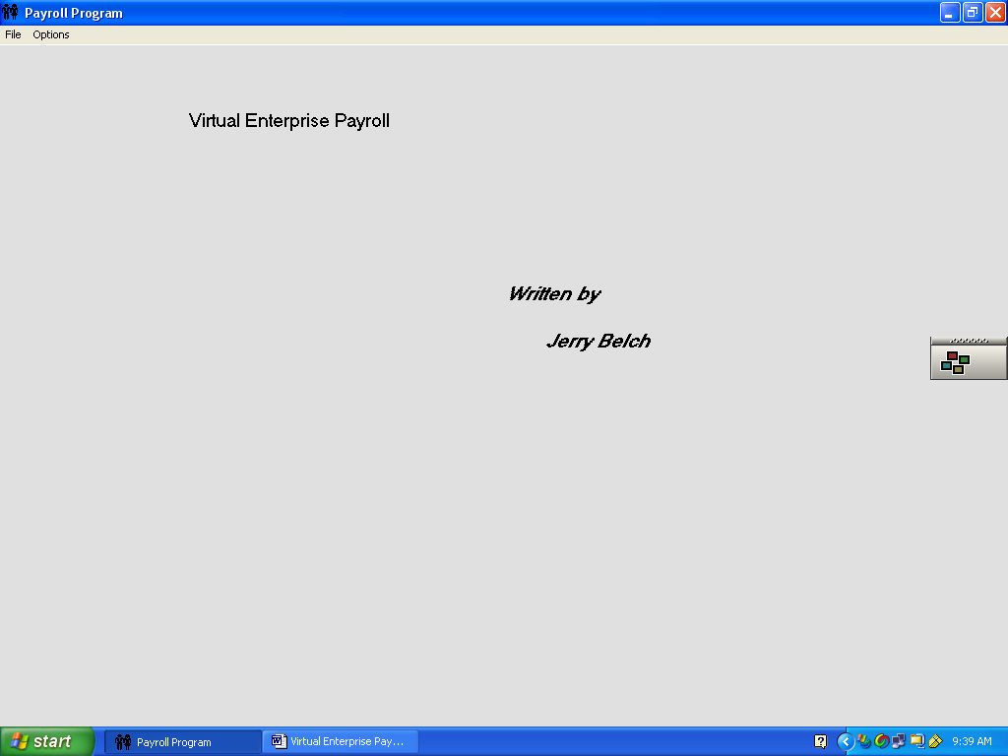

Royal Destinations is a travel agency located in Santa Barbara, California at 3712 Camino Real, Santa Barbara, CA 93101. Currently there are 17 employees. Their first day of business is July 1
1. Click on Options on the menu bar
- From the drop down menu, select Company Information
- Your screen should look like the one pictured below
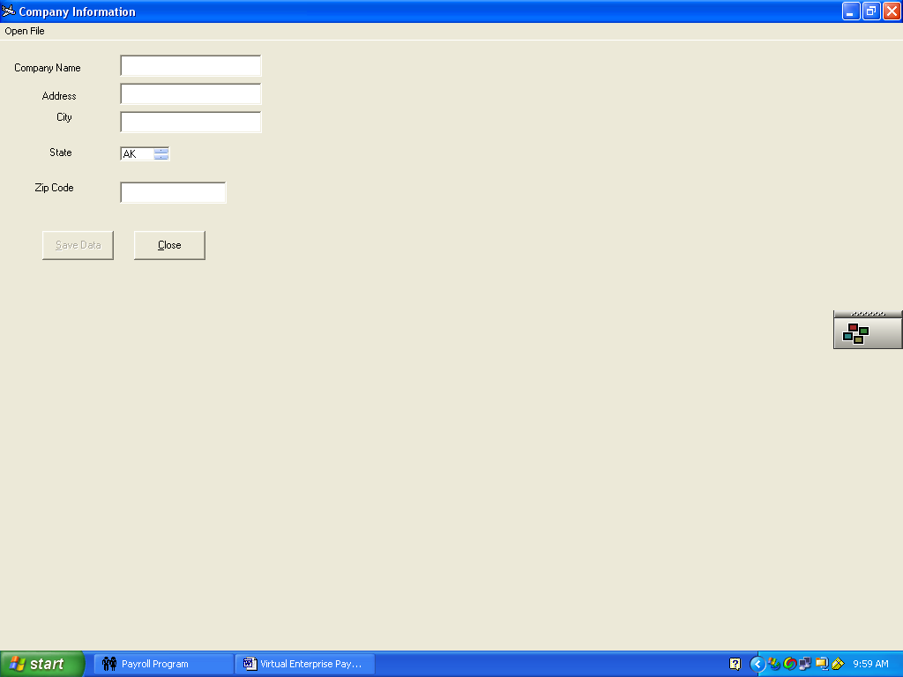
- Go to the open file selection on the menu bar.
- Go to the Look in box and decide where you want your company file to go. Note all files should be in the same place.
- Key in the file name COINFO. You must use this name. Note it is in all caps. This file is automatically retrieved as needed in the program where the checks are printed.
- Click Open
- Key in the company Name Royal Destinations
- Key in the address 3712 Camino Real
- Key in the city Santa Barbara
- Use the scroll box to find CA and click on it
- Enter the zip Code 93101
- Click Save Data command button
- Click Close command button

Exercise 2: Creating the monthly payroll file and employee earning records file/Earnings Records
Additional files are needed in the simulation. One stores the hours worked each month and the second keeps track of the employees’ payroll totals. These files must be selected for most program options to function. They appear grayed out until these files have been selected. To create these two files follow these directions.
- Click File on the menu bar.
- Click Open Monthly Payroll File
The screen should look like the one pictured below. Note the heading of the dialog box, stating that this is a monthly payroll file.
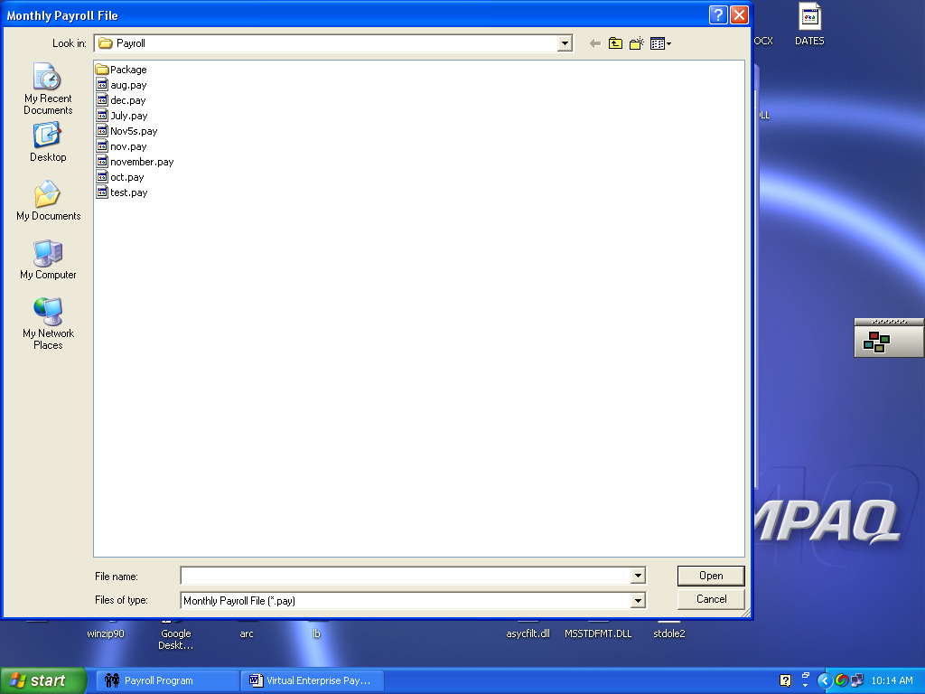
3. Use the Look In box to decide where to place your files. It should be in the same location as your company information file. Remember if you are using Windows XP and do not have administrative privileges, you must put your files in non- program folders. My Documents would be a good choice.
- To create a monthly payroll file, type in an appropriate name. A good choice would be July since we are doing a payroll for July in this simulation. An extension will be automatically added to the file name. This extension is (.pay)
4. Click Open
- Now it is time to create the employee earnings file
- Click on File
- Click on Open Employee Earning Records File

Your screen should look like the one pictured below. Note the heading on the open box, indicating “Employee Earning Records
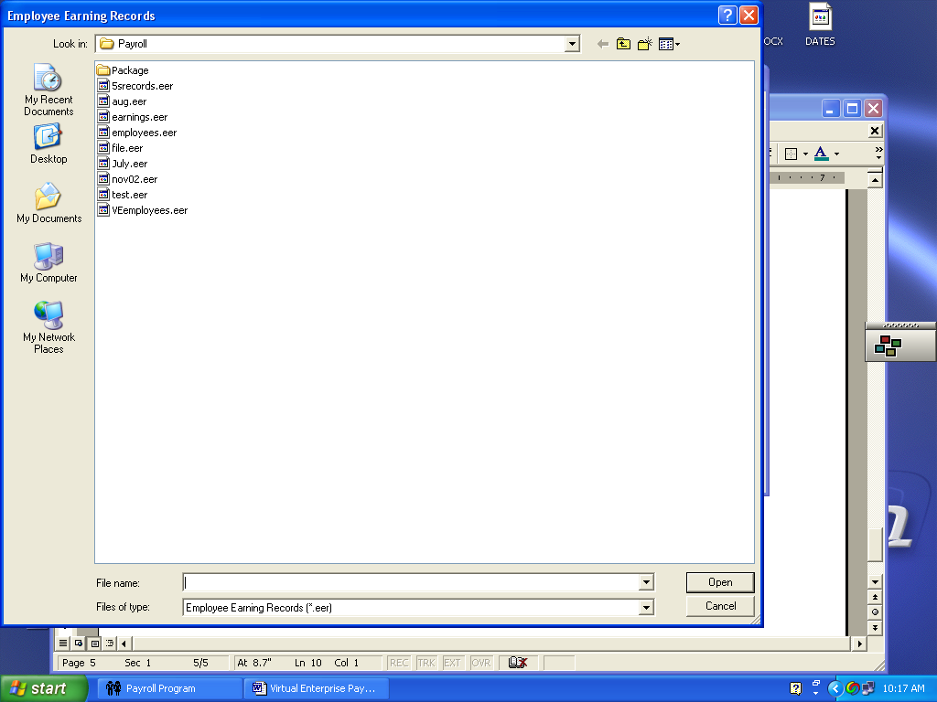

- Type an appropriate file name. A good choice would be Records. An (.eer) extension will be added automatically
- Click Open. The opening screen will return
- Select Options
- Select Employee Earning Records from the drop down list and the following screen will appear.
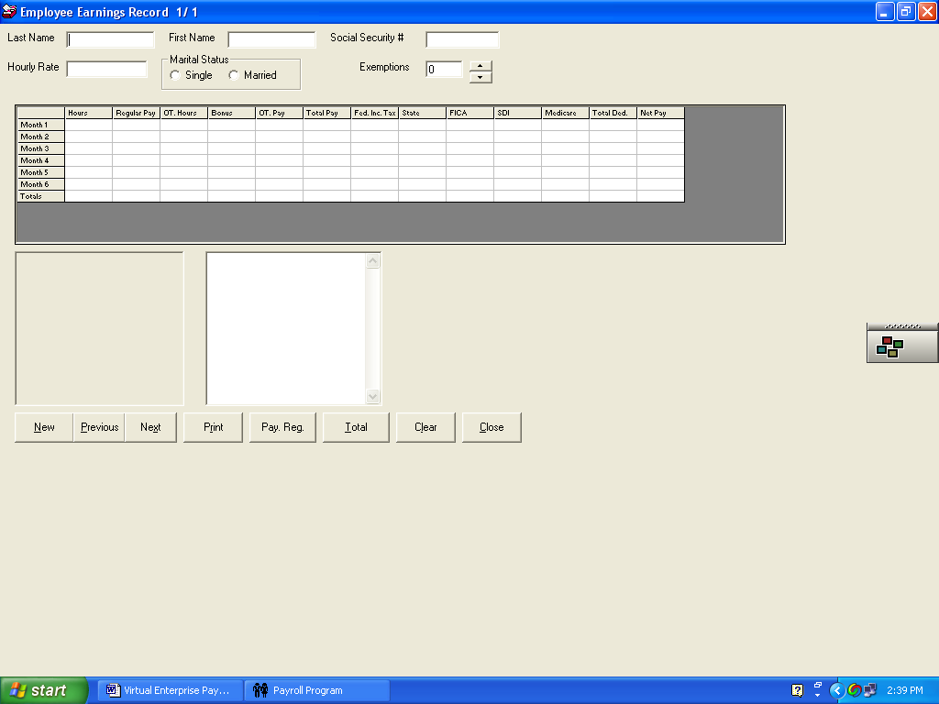
This is the input screen for employee earning records. The information we will enter here is the employee’s last name, first name, social security number, hourly rate, marital status, exemptions and job description. The actual data in the six-month grid will come from payroll registers for each of the six pay periods
Our first employee is Daryl Newman
- Type Newman in the Last Name text box and press TAB
- Type Daryl in the First name field.
- Type 551-62-5239 as the Social Security Number
- His hourly rate is 30.00. Do not type the $ sign, just key in 30
- Daryl is single. Click the radio button for Single
- Daryl claims no exemptions, type 0 or use the scroll bars to set this field equal to 0.
- In the text box below is the table where you type his job description, title and other pertinent information
- Click in the box and type Chief Executive Officer. Press Enter to advance to the next line.
- Type Duties include the supervision of all the vice presidents: Human Relations, Accounting, Marketing, Banking, Web Design, and Research and Development.
- Proof read the entire record for Daryl and make any necessary corrections.
- Click the New command button to advance to a new record for the next employee.
- Use the information in the table below to create an employee earning record for each employee at Royal Destinations

Record # | Last name | First name | Soc Sec No. | Rate of Pay | Status | Exemp | Title
2 | Ryan | Bob | 613-44-9999 | 29.50 | S | 1 | Accounting VP
3 | Thompson | Gary | 417-11-8888 | 29.50 | M | 2 | Marketing  VP
4 | Schwartz | Amanda | 618-99-1234 | 29.50 | S | 0 | Human Rel VP
5 | Kent | Greta | 441-52-6314 | 29.50 | M | 2 | Rsh/Dev VP
6 | Pointer | Chloe | 222-55-9999 | 25.00 | S | 1 | Acct Clerk
7 | Saltzman | Brittany | 111-22-5310 | 23.00 | S | 0 | Acct Clerk
8 | Villa | Luis | 813-19-8497 | 18.35 | M | 1 | Sales Rep
9 | Gonzales | Margarita | 813-19-8397 | 17.85 | M | 2 | Sales Rep
10 | Carter | Wendell | 903-12-8100 | 16.50 | S | 0 | Sales Rep
11 | Tran | David | 630-12-9190 | 22.50 | S | 1 | Hum/Rel Assist
12 | Manson | Paul | 189-91-8000 | 22.50 | S | 1 | Hum/Rel Assist
13 | Freeman | Steven | 273-19-1655 | 18.25 | S | 0 | Research Assist
14 | Green | Sharon | 491-00-8010 | 19.75 | S | 1 | Research Assist
15 | Quicksilver | Chris | 561-01-9100 | 15.00 | M | 1 | Adm.Assist
16 | Wood | Kathy | 718-90-7777 | 14.75 | S | 0 | Adm Assist
17 | Whitney | Carol | 823-19-3479 | 13.65 | S | 0 | Adm Assist

- Click Close after entering all employees
- Click File
- Click Exit to save your file.
- Back up your employee earning record file on either floppy, in another folder, flash drive or burn a CD. This file is used many times during the simulation and has payroll information written to it each month.
Exercise 3: Totaling Time Cards for July
Each employee has four time cards, one for each week in the month. The normal workday is 8 hours: From 8:00 AM to 12:00. Lunch is from noon to 1:00 PM. Work resumes from 1:00 PM to 5:00 PM. The management is not concerned with the few minutes either late or early and only gets concerned if employees are half an hour late. In that case, the employee is paid only for hours worked. For example, Amanda Schwartz came in at 8:30 AM and worked until noon, went to lunch from noon to 1:00 PM, returned at 1:00 PM and worked until 5:00PM. She would be paid for 7.5 hours.
- For each employee, total the regular hours for each day
- Overtime hours are those past 8 hours per day.
- Total each sheet for each week. Total regular and overtime hours for the entire month
Royal Destinations Weekly Time Card
NAME OF EMPLOYEE | FOR WEEK ENDING
DEPARTMENT | EXEMPTIONS

DAY | MORNING | MORNING | AFTERNOON | AFTERNOON | OT. IN | OT. OUT | REG | OT.
 | IN | OUT | IN | OUT |  |  | HOURS | HOURS
MON
TUES
WED
THURS
FRI
SAT
SUN
TOTAL

Royal Destinations Weekly Time Card
NAME OF EMPLOYEE Daryl Newman | FOR WEEK ENDING July 7
DEPARTMENT Administration | EXEMPTIONS 0

DAY | MORNING | MORNING | AFTERNOON | AFTERNOON | OT. IN | OT. OUT | REG | OT.
 | IN | OUT | IN | OUT |  |  | HOURS | HOURS
MON | 8:00 | 12:00 | 1:00 | 5:00
TUES | 7:59 | 12:02 | 12:58 | 5:03
WED | 8:00 | 12:00 | 1:01 | 5:02
THURS | 8:00 | 12:00 | 12:58 | 5:00
FRI | 7:56 | 12:01 | 1:00 | 5:01
SAT
SUN
TOTAL

Royal Destinations Weekly Time Card
NAME OF EMPLOYEE Daryl Newman | FOR WEEK ENDING July 14
DEPARTMENT Administration | EXEMPTIONS 0

DAY | MORNING | MORNING | AFTERNOON | AFTERNOON | OT. IN | OT. OUT | REG | OT.
 | IN | OUT | IN | OUT |  |  | HOURS | HOURS
MON | 8:00 | 12:01 | 1:00 | 5:01
TUES | 7:59 | 12:02 | 12:58 | 5:02
WED | 8:00 | 12:00 | 1:03 | 5:02
THURS | 8:00 | 12:00 | 12:58 | 5:00
FRI | 7:56 | 12:01 | 1:00 | 5:01
SAT
SUN
TOTAL

Royal Destinations Weekly Time Card
NAME OF EMPLOYEE Daryl Newman | FOR WEEK ENDING July 21
DEPARTMENT Administration | EXEMPTIONS 0

DAY | MORNING | MORNING | AFTERNOON | AFTERNOON | OT. IN | OT. OUT | REG | OT.
 | IN | OUT | IN | OUT |  |  | HOURS | HOURS
MON | 8:00 | 12:00 | 1:01 | 5:03
TUES | 7:59 | 12:02 | 12:58 | 5:03
WED | 8:00 | 12:00 | 1:01 | 5:02
THURS | 8:00 | 12:00 | 12:58 | 5:00
FRI | &:59 | 12:05 | 1:02 | 5:01
SAT
SUN
TOTAL

Royal Destinations Weekly Time Card
NAME OF EMPLOYEE Daryl Newman | FOR WEEK ENDING July 28
DEPARTMENT Administration | EXEMPTIONS 0

DAY | MORNING | MORNING | AFTERNOON | AFTERNOON | OT. IN | OT. OUT | REG | OT.
 | IN | OUT | IN | OUT |  |  | HOURS | HOURS
MON | 8:06 | 12:00 | 1:00 | 5:00
TUES | 7:59 | 12:02 | 12:58 | 5:03
WED | 8:00 | 12:00 | 1:01 | 5:02
THURS | 8:00 | 12:00 | 12:58 | 5:00
FRI | 7:52 | 12:02 | 1:00 | 5:01
SAT
SUN
TOTAL

Royal Destinations Weekly Time Card
NAME OF EMPLOYEE Bob Ryan | FOR WEEK ENDING July 7
DEPARTMENT Administration | EXEMPTIONS 1

DAY | MORNING | MORNING | AFTERNOON | AFTERNOON | OT. IN | OT. OUT | REG | OT.
 | IN | OUT | IN | OUT |  |  | HOURS | HOURS
MON | 8:06 | 12:01 | 1:00 | 5:00
TUES | 7:59 | 12:02 | 12:58 | 5:05
WED | 8:00 | 12:03 | 1:01 | 5:02
THURS | 8:00 | 12:00 | 12:58 | 5:02
FRI | 7:52 | 12:02 | 1:03 | 5:01
SAT
SUN
TOTAL

Royal Destinations Weekly Time Card
NAME OF EMPLOYEE Bob Ryan | FOR WEEK ENDING July 14
DEPARTMENT Administration | EXEMPTIONS 1

DAY | MORNING | MORNING | AFTERNOON | AFTERNOON | OT. IN | OT. OUT | REG | OT.
 | IN | OUT | IN | OUT |  |  | HOURS | HOURS
MON | 8:06 | 12:01 | 1:00 | 5:00
TUES | 7:59 | 12:02 | 12:58 | 5:05
WED | 8:00 | 12:03 | 1:01 | 5:02
THURS | 8:00 | 12:00 | 12:58 | 5:02
FRI | 7:52 | 12:02 | 1:03 | 5:01
SAT
SUN
TOTAL

Royal Destinations Weekly Time Card
NAME OF EMPLOYEE Bob Ryan | FOR WEEK ENDING July 21
DEPARTMENT Administration | EXEMPTIONS 1

DAY | MORNING | MORNING | AFTERNOON | AFTERNOON | OT. IN | OT. OUT | REG | OT.
 | IN | OUT | IN | OUT |  |  | HOURS | HOURS
MON | 8:06 | 12:01 | 1:00 | 5:00
TUES | 7:59 | 12:02 | 12:58 | 5:03
WED | 8:00 | 12:03 | 1:03 | 5:02
THURS | 8:00 | 12:00 | 12:59 | 5:02
FRI | 7:52 | 12:02 | 1:03 | 5:01
SAT
SUN
TOTAL

Royal Destinations Weekly Time Card
NAME OF EMPLOYEE Bob Ryan | FOR WEEK ENDING July 28
DEPARTMENT Administration | EXEMPTIONS 1

DAY | MORNING | MORNING | AFTERNOON | AFTERNOON | OT. IN | OT. OUT | REG | OT.
 | IN | OUT | IN | OUT |  |  | HOURS | HOURS
MON | 8:06 | 12:01 | 1:05 | 5:00
TUES | 7:59 | 12:02 | 12:58 | 5:05
WED | 8:00 | 12:03 | 1:01 | 5:02
THURS | 8:00 | 12:01 | 12:58 | 5:02
FRI | *:00 | 12:02 | 1:03 | 5:01 | 5:00 | 7:00
SAT
SUN
TOTAL

Royal Destinations Weekly Time Card
NAME OF EMPLOYEE Gary Thompson | FOR WEEK ENDING July 7
DEPARTMENT Administration | EXEMPTIONS 2

DAY | MORNING | MORNING | AFTERNOON | AFTERNOON | OT. IN | OT. OUT | REG | OT.
 | IN | OUT | IN | OUT |  |  | HOURS | HOURS
MON | 8:06 | 12:01 | 1:00 | 5:00
TUES | 7:59 | 12:02 | 12:58 | 5:05
WED | 8:00 | 12:03 | 1:01 | 5:02
THURS | 8:00 | 12:00 | 12:58 | 5:02
FRI | 7:52 | 12:02 | 1:03 | 5:01
SAT
SUN
TOTAL

Royal Destinations Weekly Time Card
NAME OF EMPLOYEE Gary Thompson | FOR WEEK ENDING July 14
DEPARTMENT Administration | EXEMPTIONS 2

DAY | MORNING | MORNING | AFTERNOON | AFTERNOON | OT. IN | OT. OUT | REG | OT.
 | IN | OUT | IN | OUT |  |  | HOURS | HOURS
MON | 8:06 | 12:01 | 1:00 | 5:00
TUES | 7:59 | 12:02 | 12:58 | 5:05
WED | 8:00 | 12:03 | 1:01 | 5:02
THURS | 8:00 | 12:00 | 12:58 | 5:02
FRI | 7:52 | 12:02 | 1:05 | 5:01
SAT
SUN
TOTAL

Royal Destinations Weekly Time Card
NAME OF EMPLOYEE Gary Thompson | FOR WEEK ENDING July 21
DEPARTMENT Administration | EXEMPTIONS 2

DAY | MORNING | MORNING | AFTERNOON | AFTERNOON | OT. IN | OT. OUT | REG | OT.
 | IN | OUT | IN | OUT |  |  | HOURS | HOURS
MON | 8:06 | 12:01 | 1:05 | 5:00
TUES | 7:59 | 12:02 | 12:58 | 5:05
WED | 7:56 | 12:03 | 1:01 | 5:02
THURS | 8:00 | 12:00 | 12:58 | 5:02
FRI | 7:52 | 12:02 | 1:03 | 5:01
SAT
SUN
TOTAL

Royal Destinations Weekly Time Card
NAME OF EMPLOYEE Gary Thompson | FOR WEEK ENDING July 28
DEPARTMENT Administration | EXEMPTIONS 2

DAY | MORNING | MORNING | AFTERNOON | AFTERNOON | OT. IN | OT. OUT | REG | OT.
 | IN | OUT | IN | OUT |  |  | HOURS | HOURS
MON | 8:06 | 12:01 | 1:00 | 5:00
TUES | 7:59 | 12:02 | 12:58 | 5:05
WED | 8:00 | 12:03 | 1:05 | 5:04
THURS | 8:00 | 12:00 | 12:58 | 5:02
FRI | 7:52 | 12:02 | 1:03 | 5:03
SAT
SUN
TOTAL

Royal Destinations Weekly Time Card
NAME OF EMPLOYEE Amanda Schwartz | FOR WEEK ENDING July 7
DEPARTMENT Administration | EXEMPTIONS 0

DAY | MORNING | MORNING | AFTERNOON | AFTERNOON | OT. IN | OT. OUT | REG | OT.
 | IN | OUT | IN | OUT |  |  | HOURS | HOURS
MON | 8:06 | 12:01 | 1:00 | 5:00
TUES | 7:59 | 12:02 | 12:58 | 5:05
WED | 8:00 | 12:03 | 1:01 | 5:02
THURS | 8:00 | 12:00 | 12:58 | 5:02
FRI | 7:52 | 12:02 | 1:03 | 5:01
SAT
SUN
TOTAL

Royal Destinations Weekly Time Card
NAME OF EMPLOYEE Amanda Schwartz | FOR WEEK ENDING July 14
DEPARTMENT Administration | EXEMPTIONS 0

DAY | MORNING | MORNING | AFTERNOON | AFTERNOON | OT. IN | OT. OUT | REG | OT.
 | IN | OUT | IN | OUT |  |  | HOURS | HOURS
MON | 8:06 | 12:01 | 1:00 | 5:00
TUES | 7:59 | 12:02 | 12:58 | 5:05
WED | 8:00 | 12:03 | 1:01 | 5:02
THURS | 8:00 | 12:00 | 12:58 | 5:02 | 5;00 | 6:00
FRI | 7:52 | 12:02 | 1:03 | 5:01
SAT
SUN
TOTAL

Royal Destinations Weekly Time Card
NAME OF EMPLOYEE Amanda Schwartz | FOR WEEK ENDING July 21
DEPARTMENT Administration | EXEMPTIONS 0

DAY | MORNING | MORNING | AFTERNOON | AFTERNOON | OT. IN | OT. OUT | REG | OT.
 | IN | OUT | IN | OUT |  |  | HOURS | HOURS
MON | 8:06 | 12:01 | 1:00 | 5:00
TUES | 7:59 | 12:02 | 12:59 | 5:02
WED | 8:00 | 12:03 | 1:08 | 5:02
THURS | 8:00 | 12:00 | 12:58 | 5:07
FRI | 7:52 | 12:02 | 1:03 | 5:01
SAT
SUN
TOTAL

Royal Destinations Weekly Time Card
NAME OF EMPLOYEE Amanda Schwartz | FOR WEEK ENDING July 28
DEPARTMENT Administration | EXEMPTIONS 0

DAY | MORNING | MORNING | AFTERNOON | AFTERNOON | OT. IN | OT. OUT | REG | OT.
 | IN | OUT | IN | OUT |  |  | HOURS | HOURS
MON | 8:06 | 12:01 | 1:00 | 5:00
TUES | 7:59 | 12:02 | 12:59 | 5:02
WED | 8:00 | 12:03 | 1:08 | 5:02
THURS | 8:00 | 12:00 | 12:58 | 5:07
FRI | 7:52 | 12:02 | 1:03 | 5:01
SAT
SUN
TOTAL

Royal Destinations Weekly Time Card
NAME OF EMPLOYEE Greta Kent | FOR WEEK ENDING July 7
DEPARTMENT Administration | EXEMPTIONS 2

DAY | MORNING | MORNING | AFTERNOON | AFTERNOON | OT. IN | OT. OUT | REG | OT.
 | IN | OUT | IN | OUT |  |  | HOURS | HOURS
MON | 8:00 | 12:01 | 1:00 | 5:00
TUES | 7:59 | 12:02 | 12:59 | 5:02
WED | 8:00 | 12:03 | 1:08 | 5:02
THURS | 8:00 | 12:00 | 12:58 | 5:07
FRI | 7:52 | 12:02 | 1:03 | 5:01
SAT
SUN
TOTAL

Royal Destinations Weekly Time Card
NAME OF EMPLOYEE Greta Kent | FOR WEEK ENDING July 14
DEPARTMENT Administration | EXEMPTIONS 2

DAY | MORNING | MORNING | AFTERNOON | AFTERNOON | OT. IN | OT. OUT | REG | OT.
 | IN | OUT | IN | OUT |  |  | HOURS | HOURS
MON | 8:00 | 12:01 | 1:00 | 5:00
TUES | 7:59 | 12:02 | 12:59 | 5:02
WED | 8:00 | 12:03 | 1:08 | 5:02
THURS | 8:00 | 12:00 | 12:58 | 5:07
FRI | 7:52 | 12:02 | 1:03 | 5:01
SAT
SUN
TOTAL

Royal Destinations Weekly Time Card
NAME OF EMPLOYEE Greta Kent | FOR WEEK ENDING July 21
DEPARTMENT Administration | EXEMPTIONS 2

DAY | MORNING | MORNING | AFTERNOON | AFTERNOON | OT. IN | OT. OUT | REG | OT.
 | IN | OUT | IN | OUT |  |  | HOURS | HOURS
MON | 8:03 | 12:01 | 1:00 | 5:00
TUES | 7:59 | 12:02 | 12:59 | 5:02
WED | 8:00 | 12:03 | 1:00 | 5:02
THURS | 8:00 | 12:00 | 12:58 | 5:02
FRI | 7:52 | 12:02 | 1:03 | 5:01
SAT
SUN
TOTAL

Royal Destinations Weekly Time Card
NAME OF EMPLOYEE Greta Kent | FOR WEEK ENDING July 28
DEPARTMENT Administration | EXEMPTIONS 2

DAY | MORNING | MORNING | AFTERNOON | AFTERNOON | OT. IN | OT. OUT | REG | OT.
 | IN | OUT | IN | OUT |  |  | HOURS | HOURS
MON | 8:00 | 12:01 | 1:00 | 5:00
TUES | 7:59 | 12:02 | 12:59 | 5:02
WED | 8:00 | 12:03 | 1:03 | 5:02
THURS | 8:09 | 12:00 | 12:59 | 5:07
FRI | 7:52 | 12:02 | 1:03 | 5:01
SAT
SUN
TOTAL

Royal Destinations Weekly Time Card
NAME OF EMPLOYEE Chloe Pointer | FOR WEEK ENDING July 7
DEPARTMENT Accounting | EXEMPTIONS 1

DAY | MORNING | MORNING | AFTERNOON | AFTERNOON | OT. IN | OT. OUT | REG | OT.
 | IN | OUT | IN | OUT |  |  | HOURS | HOURS
MON | 8:00 | 12:01 | 1:00 | 5:00
TUES | 7:59 | 12:02 | 12:59 | 5:02
WED | 8:00 | 12:03 | 1:08 | 5:02
THURS | 8:00 | 12:00 | 12:58 | 5:07
FRI | 7:52 | 12:02 | 1:03 | 4:01
SAT
SUN
TOTAL

Royal Destinations Weekly Time Card
NAME OF EMPLOYEE Chloe Pointer | FOR WEEK ENDING July 14
DEPARTMENT Accounting | EXEMPTIONS 1

DAY | MORNING | MORNING | AFTERNOON | AFTERNOON | OT. IN | OT. OUT | REG | OT.
 | IN | OUT | IN | OUT |  |  | HOURS | HOURS
MON | 8:00 | 12:01 | 1:00 | 3:00
TUES | 7:59 | 12:02 | 12:59 | 5:02
WED | 8:00 | 12:03 | 1:08 | 5:02
THURS | 8:00 | 12:00 | 12:58 | 5:07
FRI | 7:52 | 12:02 | 1:03 | 5:01
SAT
SUN
TOTAL

Royal Destinations Weekly Time Card
NAME OF EMPLOYEE Chloe Pointer | FOR WEEK ENDING July 21
DEPARTMENT Accounting | EXEMPTIONS 1

DAY | MORNING | MORNING | AFTERNOON | AFTERNOON | OT. IN | OT. OUT | REG | OT.
 | IN | OUT | IN | OUT |  |  | HOURS | HOURS
MON | 8:09 | 12:01 | 1:00 | 5:00
TUES | 7:59 | 12:02 | 12:59 | 5:02
WED | 8:00 | 12:03 | 1:08 | 5:02
THURS | 8:03 | 12:01 | 12:58 | 5:07
FRI | 7:56 | 12:02 | 1:03 | 5:00
SAT
SUN
TOTAL

Royal Destinations Weekly Time Card
NAME OF EMPLOYEE Chloe Pointer | FOR WEEK ENDING July 28
DEPARTMENT Accounting | EXEMPTIONS 1

DAY | MORNING | MORNING | AFTERNOON | AFTERNOON | OT. IN | OT. OUT | REG | OT.
 | IN | OUT | IN | OUT |  |  | HOURS | HOURS
MON | 8:00 | 12:01 | 1:00 | 5:00
TUES | 7:59 | 12:02 | 12:59 | 5:02
WED | 8:00 | 12:03 | 1:08 | 5:02
THURS | 8:00 | 12:00 | 12:58 | 5:07
FRI | 7:52 | 12:02 | 1:10 | 5:01
SAT
SUN
TOTAL

Royal Destinations Weekly Time Card
NAME OF EMPLOYEE Brittany Saltzman | FOR WEEK ENDING July 7
DEPARTMENT Accounting | EXEMPTIONS 0

DAY | MORNING | MORNING | AFTERNOON | AFTERNOON | OT. IN | OT. OUT | REG | OT.
 | IN | OUT | IN | OUT |  |  | HOURS | HOURS
MON | 8:00 | 12:01 | 1:00 | 5:00 | 5:00 | 6:00
TUES | 7:59 | 12:02 | 12:59 | 5:02
WED | 8:00 | 12:03 | 1:08 | 5:02
THURS | 8:00 | 12:00 | 12:58 | 5:07
FRI | 7:52 | 12:02 | 1:10 | 5:01
SAT
SUN
TOTAL

Royal Destinations Weekly Time Card
NAME OF EMPLOYEE Brittany Saltzman | FOR WEEK ENDING July14
DEPARTMENT Accounting | EXEMPTIONS 0

DAY | MORNING | MORNING | AFTERNOON | AFTERNOON | OT. IN | OT. OUT | REG | OT.
 | IN | OUT | IN | OUT |  |  | HOURS | HOURS
MON | 8:00 | 12:01 | 1:00 | 5:00 | 5:00 | 6:02
TUES | 7:59 | 12:01 | 12:57 | 5:02
WED | 8:03 | 12:03 | 1:03 | 5:02
THURS | 8:00 | 12:00 | 12:58 | 5:07
FRI | 7:52 | 12:02 | 1:10 | 5:01
SAT
SUN
TOTAL

Royal Destinations Weekly Time Card
NAME OF EMPLOYEE Brittany Saltzman | FOR WEEK ENDING July 21
DEPARTMENT Accounting | EXEMPTIONS 0

DAY | MORNING | MORNING | AFTERNOON | AFTERNOON | OT. IN | OT. OUT | REG | OT.
 | IN | OUT | IN | OUT |  |  | HOURS | HOURS
MON | 8:00 | 12:01 | 1:00 | 5:00 | 5:00 | 6:00
TUES | 7:59 | 12:02 | 12:59 | 5:02
WED | 8:00 | 12:03 | 1:08 | 5:02
THURS | 8:00 | 12:00 | 12:58 | 5:07
FRI | 7:52 | 12:02 | 1:10 | 5:01
SAT
SUN
TOTAL
Royal Destinations Weekly Time Card
NAME OF EMPLOYEE Brittany Saltzman | FOR WEEK ENDING July 28
DEPARTMENT Accounting | EXEMPTIONS 0

DAY | MORNING | MORNING | AFTERNOON | AFTERNOON | OT. IN | OT. OUT | REG | OT.
 | IN | OUT | IN | OUT |  |  | HOURS | HOURS
MON | 8:00 | 12:01 | 1:00 | 5:00 | 5:00 | 6:00
TUES | 7:59 | 12:02 | 12:59 | 5:02
WED | 8:00 | 12:03 | 1:08 | 5:02
THURS | 8:00 | 12:00 | 12:58 | 5:07
FRI | 7:52 | 12:02 | 1:10 | 5:01
SAT
SUN
TOTAL

Royal Destinations Weekly Time Card
NAME OF EMPLOYEE Luis Villa | FOR WEEK ENDING July 7
DEPARTMENT Sales | EXEMPTIONS 1

DAY | MORNING | MORNING | AFTERNOON | AFTERNOON | OT. IN | OT. OUT | REG | OT.
 | IN | OUT | IN | OUT |  |  | HOURS | HOURS
MON | 8:00 | 12:01 | 1:00 | 5:00
TUES | 7:59 | 12:02 | 12:59 | 5:02
WED | 8:00 | 12:03 | 1:08 | 5:02
THURS | 8:00 | 12:00 | 12:58 | 5:07
FRI | 7:52 | 12:02 | 1:10 | 5:01
SAT
SUN
TOTAL

Royal Destinations Weekly Time Card
NAME OF EMPLOYEE Luis Villa | FOR WEEK ENDING July 14
DEPARTMENT Sales | EXEMPTIONS 1

DAY | MORNING | MORNING | AFTERNOON | AFTERNOON | OT. IN | OT. OUT | REG | OT.
 | IN | OUT | IN | OUT |  |  | HOURS | HOURS
MON | 8:01 | 12:01 | 1:00 | 5:00
TUES | 7:59 | 12:02 | 12:59 | 5:04
WED | 8:05 | 12:03 | 1:08 | 5:02
THURS | 8:00 | 12:00 | 12:58 | 5:07
FRI | 7:52 | 12:02 | 1:10 | 5:01
SAT
SUN
TOTAL

Royal Destinations Weekly Time Card
NAME OF EMPLOYEE Luis Villa | FOR WEEK ENDING July 21
DEPARTMENT Sales | EXEMPTIONS 1

DAY | MORNING | MORNING | AFTERNOON | AFTERNOON | OT. IN | OT. OUT | REG | OT.
 | IN | OUT | IN | OUT |  |  | HOURS | HOURS
MON | 8:00 | 12:01 | 1:00 | 5:00
TUES | 7:59 | 12:02 | 12:59 | 5:02
WED | 8:00 | 12:03 | 1:08 | 5:02
THURS | 8:00 | 12:00 | 12:58 | 5:07
FRI | 7:52 | 12:02 | 1:10 | 5:01
SAT
SUN
TOTAL

Royal Destinations Weekly Time Card
NAME OF EMPLOYEE Luis Villa | FOR WEEK ENDING July 28
DEPARTMENT Sales | EXEMPTIONS 1

DAY | MORNING | MORNING | AFTERNOON | AFTERNOON | OT. IN | OT. OUT | REG | OT.
 | IN | OUT | IN | OUT |  |  | HOURS | HOURS
MON | 8:00 | 12:01 | 1:00 | 5:00
TUES | 7:59 | 12:02 | 12:59 | 5:02
WED | 8:00 | 12:03 | 1:08 | 5:02
THURS | 8:00 | 12:00 | 12:58 | 5:07
FRI | 7:52 | 12:02 | 1:10 | 5:01
SAT
SUN
TOTAL

Royal Destinations Weekly Time Card
NAME OF EMPLOYEE Margarita Gonzales | FOR WEEK ENDING July 7
DEPARTMENT Sales | EXEMPTIONS 2

DAY | MORNING | MORNING | AFTERNOON | AFTERNOON | OT. IN | OT. OUT | REG | OT.
 | IN | OUT | IN | OUT |  |  | HOURS | HOURS
MON | 8:00 | 12:01 | 1:00 | 5:00
TUES | 7:59 | 12:02 | 12:59 | 5:02
WED | 8:00 | 12:03 | 1:08 | 5:02
THURS | 8:00 | 12:00 | 12:58 | 5:07
FRI | 7:52 | 12:02 | 1:10 | 5:01
SAT
SUN
TOTAL

Royal Destinations Weekly Time Card
NAME OF EMPLOYEE Margarita Gonzales | FOR WEEK ENDING July 14
DEPARTMENT Sales | EXEMPTIONS 2

DAY | MORNING | MORNING | AFTERNOON | AFTERNOON | OT. IN | OT. OUT | REG | OT.
 | IN | OUT | IN | OUT |  |  | HOURS | HOURS
MON | 8:00 | 12:01 | 1:00 | 4:00
TUES | 7:59 | 12:02 | 12:59 | 5:02
WED | 8:00 | 12:03 | 1:08 | 5:02
THURS | 8:00 | 12:00 | 12:58 | 5:07
FRI | 7:52 | 12:02 | 1:10 | 5:01
SAT
SUN
TOTAL

Royal Destinations Weekly Time Card
NAME OF EMPLOYEE Margarita Gonzales | FOR WEEK ENDING July 21
DEPARTMENT Sales | EXEMPTIONS 2

DAY | MORNING | MORNING | AFTERNOON | AFTERNOON | OT. IN | OT. OUT | REG | OT.
 | IN | OUT | IN | OUT |  |  | HOURS | HOURS
MON | 8:00 | 12:01 | 1:00 | 5:00
TUES | 7:59 | 12:02 | 12:59 | 5:02
WED | 8:00 | 12:03 | 1:08 | 5:02
THURS | 8:00 | 12:00 | 12:58 | 5:07
FRI | 7:52 | 12:02 | 1:10 | 5:01
SAT
SUN
TOTAL

Royal Destinations Weekly Time Card
NAME OF EMPLOYEE Margarita Gonzales | FOR WEEK ENDING July 28
DEPARTMENT Sales | EXEMPTIONS 2

DAY | MORNING | MORNING | AFTERNOON | AFTERNOON | OT. IN | OT. OUT | REG | OT.
 | IN | OUT | IN | OUT |  |  | HOURS | HOURS
MON | 8:00 | 12:01 | 1:00 | 5:00
TUES | 7:59 | 12:02 | 12:59 | 5:02
WED | 8:00 | 12:03 | 1:08 | 5:02
THURS | 8:00 | 12:00 | 12:58 | 5:07
FRI | 7:52 | 12:02 | 1:10 | 5:01
SAT
SUN
TOTAL

Royal Destinations Weekly Time Card
NAME OF EMPLOYEE Wendell Carter | FOR WEEK ENDING July 7
DEPARTMENT Sales | EXEMPTIONS 0

DAY | MORNING | MORNING | AFTERNOON | AFTERNOON | OT. IN | OT. OUT | REG | OT.
 | IN | OUT | IN | OUT |  |  | HOURS | HOURS
MON | 8:00 | 12:01 | 1:00 | 5:00
TUES | 7:59 | 12:02 | 12:59 | 5:02
WED | 8:00 | 12:03 | 1:08 | 5:02
THURS | 8:00 | 12:00 | 12:58 | 5:07
FRI | 7:52 | 12:02 | 1:03 | 5:04
SAT
SUN
TOTAL

Royal Destinations Weekly Time Card
NAME OF EMPLOYEE Wendell Carter | FOR WEEK ENDING July 14
DEPARTMENT Sales | EXEMPTIONS 0

DAY | MORNING | MORNING | AFTERNOON | AFTERNOON | OT. IN | OT. OUT | REG | OT.
 | IN | OUT | IN | OUT |  |  | HOURS | HOURS
MON | 8:00 | 12:01 | 1:00 | 5:00
TUES | 7:59 | 12:02 | 12:59 | 5:02
WED | 8:00 | 12:03 | 1:08 | 5:02
THURS | 8:00 | 12:00 | 12:58 | 5:07
FRI | 7:52 | 12:02 | 1:03 | 5:04
SAT
SUN
TOTAL

Royal Destinations Weekly Time Card
NAME OF EMPLOYEE Wendell Carter | FOR WEEK ENDING July 21
DEPARTMENT Sales | EXEMPTIONS 0

DAY | MORNING | MORNING | AFTERNOON | AFTERNOON | OT. IN | OT. OUT | REG | OT.
 | IN | OUT | IN | OUT |  |  | HOURS | HOURS
MON | 8:00 | 12:01 | 1:00 | 5:00
TUES | 7:59 | 12:02 | 12:59 | 4:59
WED | 8:00 | 12:03 | 1:08 | 5:02
THURS | 8:00 | 12:00 | 12:58 | 5:07
FRI | 7:52 | 12:02 | 1:03 | 5:04
SAT
SUN
TOTAL

Royal Destinations Weekly Time Card
NAME OF EMPLOYEE Wendell Carter | FOR WEEK ENDING July 28
DEPARTMENT Sales | EXEMPTIONS 0

DAY | MORNING | MORNING | AFTERNOON | AFTERNOON | OT. IN | OT. OUT | REG | OT.
 | IN | OUT | IN | OUT |  |  | HOURS | HOURS
MON | 8:00 | 12:01 | 1:00 | 5:00
TUES | 7:59 | 12:02 | 12:59 | 5:02
WED | 8:00 | 12:03 | 1:08 | 5:02
THURS | 8:00 | 12:00 | 12:58 | 5:07
FRI | 7:52 | 12:02 | 1:03 | 5:04
SAT
SUN
TOTAL

Royal Destinations Weekly Time Card
NAME OF EMPLOYEE David Tran | FOR WEEK ENDING July 7
DEPARTMENT Human Resources | EXEMPTIONS 1

DAY | MORNING | MORNING | AFTERNOON | AFTERNOON | OT. IN | OT. OUT | REG | OT.
 | IN | OUT | IN | OUT |  |  | HOURS | HOURS
MON | 8:00 | 12:01 | 1:00 | 5:00
TUES | 7:59 | 12:02 | 12:59 | 5:02
WED | 8:00 | 12:03 | 1:08 | 5:02
THURS | 8:00 | 12:00 | 12:58 | 5:07 | 6:00 | 9:00
FRI | 7:52 | 12:02 | 1:03 | 5:04
SAT
SUN
TOTAL

Royal Destinations Weekly Time Card
NAME OF EMPLOYEE David Tran | FOR WEEK ENDING July 14
DEPARTMENT Human Resources | EXEMPTIONS 1

DAY | MORNING | MORNING | AFTERNOON | AFTERNOON | OT. IN | OT. OUT | REG | OT.
 | IN | OUT | IN | OUT |  |  | HOURS | HOURS
MON | 8:00 | 12:01 | 1:00 | 5:00
TUES | 7:59 | 12:02 | 12:59 | 5:02
WED | 8:00 | 12:03 | 1:08 | 5:02
THURS | 8:00 | 12:00 | 12:58 | 5:07
FRI | 7:52 | 12:02 | 1:03 | 5:04
SAT
SUN
TOTAL

Royal Destinations Weekly Time Card
NAME OF EMPLOYEE David Tran | FOR WEEK ENDING July 21
DEPARTMENT Human Resources | EXEMPTIONS 1

DAY | MORNING | MORNING | AFTERNOON | AFTERNOON | OT. IN | OT. OUT | REG | OT.
 | IN | OUT | IN | OUT |  |  | HOURS | HOURS
MON | 8:00 | 12:01 | 1:00 | 5:00
TUES | 7:59 | 12:02 | 12:59 | 5:02
WED | 8:00 | 12:03 | 1:08 | 5:02
THURS | 8:00 | 12:00 | 12:58 | 5:07
FRI | 7:52 | 12:02 | 1:03 | 5:04
SAT
SUN
TOTAL

Royal Destinations Weekly Time Card
NAME OF EMPLOYEE David Tran | FOR WEEK ENDING July 28
DEPARTMENT Human Resources | EXEMPTIONS 1

DAY | MORNING | MORNING | AFTERNOON | AFTERNOON | OT. IN | OT. OUT | REG | OT.
 | IN | OUT | IN | OUT |  |  | HOURS | HOURS
MON | 8:00 | 12:01 | 1:00 | 5:00
TUES | 7:59 | 12:02 | 12:59 | 5:02
WED | 8:00 | 12:03 | 1:08 | 5:02
THURS | 8:00 | 12:00 | 12:58 | 5:07
FRI | 7:52 | 12:02 | 1:03 | 5:04
SAT
SUN
TOTAL

Royal Destinations Weekly Time Card
NAME OF EMPLOYEE Paul Manson | FOR WEEK ENDING July 7
DEPARTMENT Human Resources | EXEMPTIONS 1

DAY | MORNING | MORNING | AFTERNOON | AFTERNOON | OT. IN | OT. OUT | REG | OT.
 | IN | OUT | IN | OUT |  |  | HOURS | HOURS
MON | 8:00 | 12:01 | 1:00 | 5:00
TUES | 7:59 | 12:02 | 12:59 | 5:02
WED | 8:00 | 12:03 | 1:08 | 5:02
THURS | 8:00 | 12:00 | 12:58 | 5:07
FRI | 7:52 | 12:02 | 1:03 | 5:04
SAT
SUN
TOTAL

Royal Destinations Weekly Time Card
NAME OF EMPLOYEE Paul Manson | FOR WEEK ENDING July 14
DEPARTMENT Human Resources | EXEMPTIONS 1

DAY | MORNING | MORNING | AFTERNOON | AFTERNOON | OT. IN | OT. OUT | REG | OT.
 | IN | OUT | IN | OUT |  |  | HOURS | HOURS
MON | 8:00 | 12:01 | 1:00 | 5:00
TUES | 7:59 | 12:02 | 12:59 | 5:02
WED | 8:00 | 12:03 | 1:08 | 5:02
THURS | 8:00 | 12:00 | 12:58 | 5:07
FRI | 7:52 | 12:02 | 1:03 | 5:04
SAT
SUN
TOTAL

Royal Destinations Weekly Time Card
NAME OF EMPLOYEE Paul Manson | FOR WEEK ENDING July 21
DEPARTMENT Human Resources | EXEMPTIONS 1

DAY | MORNING | MORNING | AFTERNOON | AFTERNOON | OT. IN | OT. OUT | REG | OT.
 | IN | OUT | IN | OUT |  |  | HOURS | HOURS
MON | 8:00 | 12:01 | 1:00 | 5:00
TUES | 7:59 | 12:02 | 12:59 | 5:02
WED | 8:00 | 12:03 | 1:08 | 5:02
THURS | 8:00 | 12:00 | 12:58 | 5:07
FRI | 7:52 | 12:02 | 1:03 | 5:04
SAT
SUN
TOTAL

Royal Destinations Weekly Time Card
NAME OF EMPLOYEE Paul Manson | FOR WEEK ENDING July 28
DEPARTMENT Human Resources | EXEMPTIONS 1

DAY | MORNING | MORNING | AFTERNOON | AFTERNOON | OT. IN | OT. OUT | REG | OT.
 | IN | OUT | IN | OUT |  |  | HOURS | HOURS
MON | 8:00 | 12:01 | 1:00 | 5:00
TUES | 7:59 | 12:02 | 12:59 | 5:02
WED | 8:00 | 12:03 | 1:08 | 5:02
THURS | 8:00 | 12:00 | 12:58 | 5:07
FRI | 7:52 | 12:02 | 1:03 | 5:04
SAT
SUN
TOTAL

Royal Destinations Weekly Time Card
NAME OF EMPLOYEE Steven Freeman | FOR WEEK ENDING July 7
DEPARTMENT Research and Development | EXEMPTIONS 0

DAY | MORNING | MORNING | AFTERNOON | AFTERNOON | OT. IN | OT. OUT | REG | OT.
 | IN | OUT | IN | OUT |  |  | HOURS | HOURS
MON | 8:00 | 12:01 | 1:00 | 5:00
TUES | 7:59 | 12:02 | 12:59 | 5:02
WED | 8:00 | 12:03 | 1:08 | 5:02
THURS | 8:00 | 12:00 | 12:58 | 5:07
FRI | 7:52 | 12:02 | 1:03 | 5:04
SAT
SUN
TOTAL

Royal Destinations Weekly Time Card
NAME OF EMPLOYEE Steven Freeman | FOR WEEK ENDING July 14
DEPARTMENT Research and Development | EXEMPTIONS 0

DAY | MORNING | MORNING | AFTERNOON | AFTERNOON | OT. IN | OT. OUT | REG | OT.
 | IN | OUT | IN | OUT |  |  | HOURS | HOURS
MON | 8:00 | 12:01 | 1:00 | 5:00
TUES | 7:59 | 12:02 | 12:59 | 5:02
WED | 8:00 | 12:03 | 1:08 | 5:02
THURS | 8:00 | 12:00 | 12:58 | 5:07
FRI | 7:52 | 12:02 | 1:03 | 5:04
SAT
SUN
TOTAL

Royal Destinations Weekly Time Card
NAME OF EMPLOYEE Steven Freeman | FOR WEEK ENDING July 21
DEPARTMENT Research and Development | EXEMPTIONS 0

DAY | MORNING | MORNING | AFTERNOON | AFTERNOON | OT. IN | OT. OUT | REG | OT.
 | IN | OUT | IN | OUT |  |  | HOURS | HOURS
MON | 8:00 | 12:01 | 1:00 | 5:00
TUES | 7:59 | 12:02 | 12:59 | 5:02
WED | 8:00 | 12:03 | 1:02 | 5:05
THURS | 8:00 | 12:00 | 12:59 | 5:07
FRI | 7:52 | 12:02 | 1:01 | 5:04
SAT
SUN
TOTAL

Royal Destinations Weekly Time Card
NAME OF EMPLOYEE Steven Freeman | FOR WEEK ENDING July 28
DEPARTMENT Research and Development | EXEMPTIONS 0

DAY | MORNING | MORNING | AFTERNOON | AFTERNOON | OT. IN | OT. OUT | REG | OT.
 | IN | OUT | IN | OUT |  |  | HOURS | HOURS
MON | 8:00 | 12:01 | 1:00 | 5:00
TUES | 7:59 | 12:02 | 12:59 | 5:02
WED | 8:00 | 12:03 | 1:08 | 5:02
THURS | 8:00 | 12:00 | 12:58 | 5:07
FRI | 7:52 | 12:02 | 1:03 | 5:04
SAT
SUN
TOTAL

Royal Destinations Weekly Time Card
NAME OF EMPLOYEE Sharon Green | FOR WEEK ENDING July 7
DEPARTMENT Research and Development | EXEMPTIONS 1

DAY | MORNING | MORNING | AFTERNOON | AFTERNOON | OT. IN | OT. OUT | REG | OT.
 | IN | OUT | IN | OUT | 6:00 | 7:00 | HOURS | HOURS
MON | 8:00 | 12:01 | 1:00 | 5:00
TUES | 7:59 | 12:02 | 12:59 | 5:02
WED | 8:00 | 12:03 | 1:08 | 5:02
THURS | 8:00 | 12:00 | 12:58 | 5:07
FRI | 7:52 | 12:02 | 1:03 | 5:04
SAT
SUN
TOTAL

Royal Destinations Weekly Time Card
NAME OF EMPLOYEE Sharon Green | FOR WEEK ENDING July 14
DEPARTMENT Research and Development | EXEMPTIONS 1

DAY | MORNING | MORNING | AFTERNOON | AFTERNOON | OT. IN | OT. OUT | REG | OT.
 | IN | OUT | IN | OUT |  |  | HOURS | HOURS
MON | 8:00 | 12:01 | 1:00 | 5:00 | 6:00 | 7:00
TUES | 7:59 | 12:02 | 12:59 | 5:02 | 6:00 | 7:00
WED | 8:00 | 12:03 | 1:08 | 5:02
THURS | 8:00 | 12:00 | 12:58 | 5:07
FRI | 7:52 | 12:02 | 1:03 | 5:04
SAT
SUN
TOTAL

Royal Destinations Weekly Time Card
NAME OF EMPLOYEE Sharon Green | FOR WEEK ENDING July 21
DEPARTMENT Research and Development | EXEMPTIONS 1

DAY | MORNING | MORNING | AFTERNOON | AFTERNOON | OT. IN | OT. OUT | REG | OT.
 | IN | OUT | IN | OUT |  |  | HOURS | HOURS
MON | 8:00 | 12:01 | 1:00 | 5:00 | 6:00 | 7:03
TUES | 7:59 | 12:02 | 12:59 | 5:02
WED | 8:00 | 12:03 | 1:08 | 5:02
THURS | 8:00 | 12:00 | 12:58 | 5:07
FRI | 7:52 | 12:02 | 1:03 | 5:04
SAT
SUN
TOTAL

Royal Destinations Weekly Time Card
NAME OF EMPLOYEE Sharon Green | FOR WEEK ENDING July 28
DEPARTMENT Research and Development | EXEMPTIONS 1

DAY | MORNING | MORNING | AFTERNOON | AFTERNOON | OT. IN | OT. OUT | REG | OT.
 | IN | OUT | IN | OUT |  |  | HOURS | HOURS
MON | 8:00 | 12:01 | 1:00 | 5:00 | 6:00 | 7:03
TUES | 7:59 | 12:02 | 12:59 | 5:02
WED | 8:00 | 12:03 | 1:08 | 5:02
THURS | 8:00 | 12:00 | 12:58 | 5:07
FRI | 7:52 | 12:02 | 1:03 | 5:04
SAT
SUN
TOTAL

Royal Destinations Weekly Time Card
NAME OF EMPLOYEE Chris Quicksilver | FOR WEEK ENDING July 7
DEPARTMENT Administrative Assistant | EXEMPTIONS 1

DAY | MORNING | MORNING | AFTERNOON | AFTERNOON | OT. IN | OT. OUT | REG | OT.
 | IN | OUT | IN | OUT |  |  | HOURS | HOURS
MON | 8:00 | 12:01 | 1:00 | 5:00 | 6:00 | 7:00
TUES | 7:59 | 12:02 | 12:59 | 5:02
WED | 8:00 | 12:03 | 1:08 | 5:02
THURS | 8:00 | 12:00 | 12:58 | 5:07
FRI | 7:52 | 12:02 | 1:03 | 5:04
SAT
SUN
TOTAL

Royal Destinations Weekly Time Card
NAME OF EMPLOYEE Chris Quicksilver | FOR WEEK ENDING July 14
DEPARTMENT Administrative Assistant | EXEMPTIONS 1

DAY | MORNING | MORNING | AFTERNOON | AFTERNOON | OT. IN | OT. OUT | REG | OT.
 | IN | OUT | IN | OUT |  |  | HOURS | HOURS
MON | 8:00 | 12:01 | 1:00 | 5:00 | 6:00 | 7:00
TUES | 7:59 | 12:02 | 12:59 | 5:02
WED | 8:00 | 12:03 | 1:08 | 5:02
THURS | 8:00 | 12:00 | 12:58 | 5:07
FRI | 7:52 | 12:02 | 1:03 | 5:04
SAT |  |  |  |  | 8:00 | 12:00
SUN
TOTAL

Royal Destinations Weekly Time Card
NAME OF EMPLOYEE Chris Quicksilver | FOR WEEK ENDING July 21
DEPARTMENT Administrative Assistant | EXEMPTIONS 1

DAY | MORNING | MORNING | AFTERNOON | AFTERNOON | OT. IN | OT. OUT | REG | OT.
 | IN | OUT | IN | OUT |  |  | HOURS | HOURS
MON | 8:00 | 12:01 | 1:00 | 5:00
TUES | 7:59 | 12:02 | 12:59 | 5:02
WED | 8:00 | 12:03 | 1:08 | 5:02
THURS | 8:00 | 12:00 | 12:58 | 5:07
FRI | 7:52 | 12:02 | 1:03 | 5:04
SAT
SUN
TOTAL

Royal Destinations Weekly Time Card
NAME OF EMPLOYEE Chris Quicksilver | FOR WEEK ENDING July 28
DEPARTMENT Administrative Assistant | EXEMPTIONS 1

DAY | MORNING | MORNING | AFTERNOON | AFTERNOON | OT. IN | OT. OUT | REG | OT.
 | IN | OUT | IN | OUT |  |  | HOURS | HOURS
MON | 8:02 | 12:01 | 1:00 | 5:08
TUES | 7:59 | 12:02 | 12:59 | 5:02
WED | 8:00 | 12:05 | 1:08 | 5:02
THURS | 8:00 | 12:00 | 12:58 | 5:07
FRI | 7:52 | 12:02 | 1:03 | 5:04
SAT
SUN
TOTAL

Royal Destinations Weekly Time Card
NAME OF EMPLOYEE Kathy Wood | FOR WEEK ENDING July 7
DEPARTMENT Administrative Assistant | EXEMPTIONS 0

DAY | MORNING | MORNING | AFTERNOON | AFTERNOON | OT. IN | OT. OUT | REG | OT.
 | IN | OUT | IN | OUT |  |  | HOURS | HOURS
MON | 8:00 | 12:01 | 1:00 | 5:00 | 6:00 | 7:00
TUES | 7:59 | 12:02 | 12:59 | 5:02
WED | 8:00 | 12:03 | 1:08 | 5:02
THURS | 8:00 | 12:00 | 12:58 | 5:07
FRI | 7:52 | 12:02 | 1:03 | 5:04
SAT
SUN
TOTAL

Royal Destinations Weekly Time Card
NAME OF EMPLOYEE Chris Quicksilver | FOR WEEK ENDING July 14
DEPARTMENT Administrative Assistant | EXEMPTIONS 1

DAY | MORNING | MORNING | AFTERNOON | AFTERNOON | OT. IN | OT. OUT | REG | OT.
 | IN | OUT | IN | OUT |  |  | HOURS | HOURS
MON | 8:00 | 12:01 | 1:00 | 5:00 | 6:00 | 7:00
TUES | 7:59 | 12:02 | 12:59 | 5:02
WED | 8:00 | 12:03 | 1:08 | 5:02
THURS | 8:00 | 12:00 | 12:58 | 5:07
FRI | 7:52 | 12:02 | 1:03 | 5:04
SAT
SUN
TOTAL

Royal Destinations Weekly Time Card
NAME OF EMPLOYEE Chris Quicksilver | FOR WEEK ENDING July 21
DEPARTMENT Administrative Assistant | EXEMPTIONS 1

DAY | MORNING | MORNING | AFTERNOON | AFTERNOON | OT. IN | OT. OUT | REG | OT.
 | IN | OUT | IN | OUT |  |  | HOURS | HOURS
MON | 8:00 | 12:01 | 1:00 | 5:00 | 6:00 | 7:00
TUES | 7:59 | 12:02 | 12:59 | 5:02
WED | 8:00 | 12:03 | 1:01 | 5:02
THURS | 8:00 | 12:00 | 12:55 | 5:07
FRI | 7:52 | 12:02 | 1:01 | 5:04
SAT
SUN
TOTAL

Royal Destinations Weekly Time Card
NAME OF EMPLOYEE Chris Quicksilver | FOR WEEK ENDING July 28
DEPARTMENT Administrative Assistant | EXEMPTIONS 1

DAY | MORNING | MORNING | AFTERNOON | AFTERNOON | OT. IN | OT. OUT | REG | OT.
 | IN | OUT | IN | OUT |  |  | HOURS | HOURS
MON | 8:00 | 12:01 | 1:00 | 5:00 | 6:00 | 7:00
TUES | 7:59 | 12:02 | 12:59 | 5:02
WED | 8:00 | 12:03 | 1:08 | 5:02
THURS | 8:00 | 12:00 | 12:58 | 5:07
FRI | 7:52 | 12:02 | 1:03 | 5:04
SAT
SUN
TOTAL

Royal Destinations Weekly Time Card
NAME OF EMPLOYEE Carol Whitney | FOR WEEK ENDING July 7
DEPARTMENT Administrative Assistant | EXEMPTIONS 1

DAY | MORNING | MORNING | AFTERNOON | AFTERNOON | OT. IN | OT. OUT | REG | OT.
 | IN | OUT | IN | OUT |  |  | HOURS | HOURS
MON | 8:00 | 12:01 | 1:00 | 5:00 | 5:00 | 7:00
TUES | 7:59 | 12:02 | 12:59 | 5:02
WED | 8:00 | 12:03 | 1:08 | 5:02
THURS | 8:00 | 12:00 | 12:58 | 5:07
FRI | 7:52 | 12:02 | 1:03 | 5:04
SAT
SUN
TOTAL

Royal Destinations Weekly Time Card
NAME OF EMPLOYEE Carol Whitney | FOR WEEK ENDING July 14
DEPARTMENT Administrative Assistant | EXEMPTIONS 1

DAY | MORNING | MORNING | AFTERNOON | AFTERNOON | OT. IN | OT. OUT | REG | OT.
 | IN | OUT | IN | OUT |  |  | HOURS | HOURS
MON | 8:00 | 12:01 | 1:00 | 5:00 | 5:00 | 7:00
TUES | 7:59 | 12:02 | 12:59 | 5:02
WED | 8:00 | 12:03 | 1:08 | 5:02
THURS | 8:00 | 12:00 | 12:58 | 5:07
FRI | 7:52 | 12:02 | 1:03 | 5:04
SAT
SUN
TOTAL

Royal Destinations Weekly Time Card
NAME OF EMPLOYEE Carol Whitney | FOR WEEK ENDING July 21
DEPARTMENT Administrative Assistant | EXEMPTIONS 1

DAY | MORNING | MORNING | AFTERNOON | AFTERNOON | OT. IN | OT. OUT | REG | OT.
 | IN | OUT | IN | OUT |  |  | HOURS | HOURS
MON | 8:00 | 12:01 | 1:00 | 5:00 | 5:00 | 7:00
TUES | 7:59 | 12:02 | 12:59 | 5:02
WED | 8:00 | 12:03 | 1:08 | 5:02
THURS | 8:00 | 12:00 | 12:58 | 5:07
FRI | 7:52 | 12:02 | 1:03 | 5:04
SAT
SUN
TOTAL

Royal Destinations Weekly Time Card
NAME OF EMPLOYEE Carol Whitney | FOR WEEK ENDING July 28
DEPARTMENT Administrative Assistant | EXEMPTIONS 1

DAY | MORNING | MORNING | AFTERNOON | AFTERNOON | OT. IN | OT. OUT | REG | OT.
 | IN | OUT | IN | OUT |  |  | HOURS | HOURS
MON | 8:00 | 12:01 | 1:00 | 5:00 | 5:00 | 7:00
TUES | 7:59 | 12:02 | 12:59 | 5:02
WED | 8:00 | 12:03 | 1:08 | 5:02
THURS | 8:00 | 12:00 | 12:58 | 5:07 | 5:00 | 7:03
FRI | 7:52 | 12:02 | 1:03 | 5:04
SAT
SUN
TOTAL

Exercise 4: Entering the hours worked
- Click File
- Click Open File
- Type July in the filename box for Monthly Payroll or Click on it if you have already created it.
- Click Open
- Now it is time to open the employee earning file you have already created
- Use the scroll bars if necessary to locate the earnings file
- Click on the file name.
- Click Open
- Click Options
- Click Hours
- A message box will appear asking you if this is a new file. Answer yes, since no hours have been entered yet.
- Your screen should look like the one pictured below
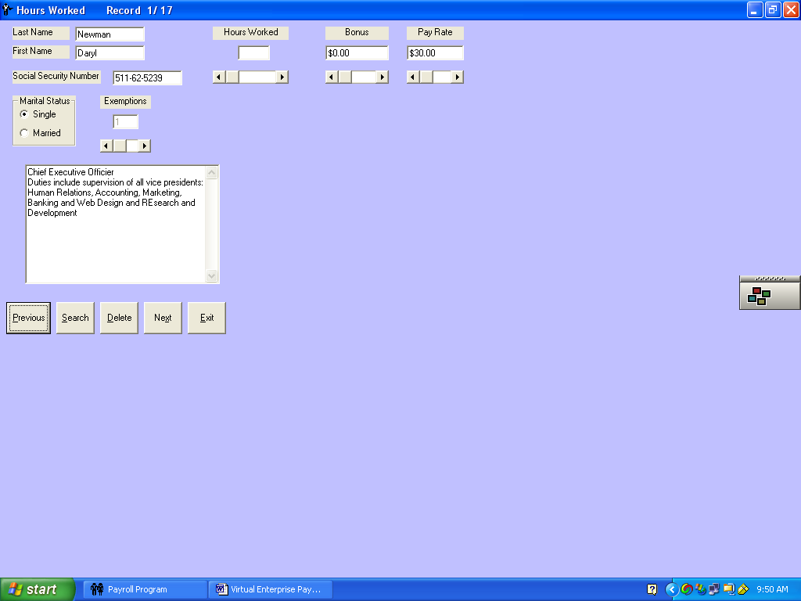
- This is Daryl Newman’s record. Look at his total hours for the month from the four weekly time cards
- Use the scroll bar to set the hours worked. If you calculated correctly, you should come up with 160. Set his hours to 160. You may also key in the 160 if you wish. Hours over 160 are calculated as overtime.
- Click Next to go to the next employee
- Enter the hours worked for the next employee
- Enter all hours for all employees.
- Do not worry about hours that are overtime, the computer software will take care of that for you. Just enter their total hours
- Click Close when you are finished
- File
- Exit the program
- Back up this monthly payroll file on a floppy, flash drive, in another folder or burn a CD
- If you need to edit the monthly, hourly payroll file, you will need to key in each employee’s hours again.
Exercise 5: Viewing/Printing the Payroll Register
- Click File if files have not been selected
- Click Open Monthly Payroll File
- Click on July monthly payroll file
- Click Open
- Click on the File
- Click Open Employee Earning Records File
- Click on Records. Assuming that is what you called your file.
- Click Open
- Click Options
- Click on Payroll Register from the drop-down menu
- Your screen should look like the one below.
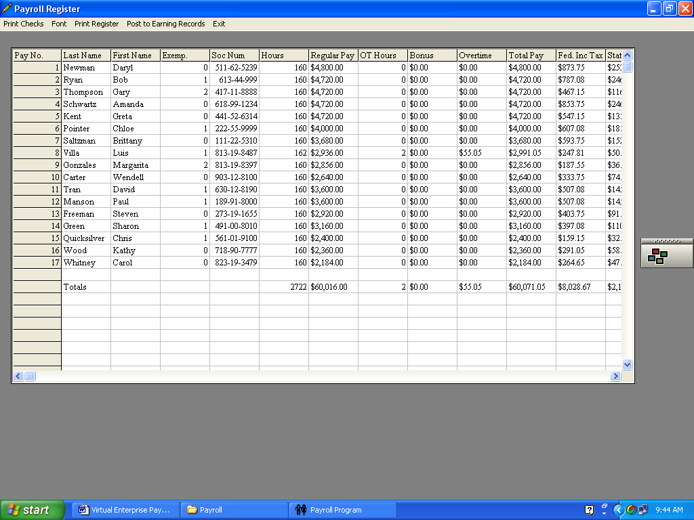
- Scroll down and across to verify that the register is complete.
Signed_________________________ Date ____________________
- Fill in the totals listed at the bottom of each column
- Total hours ____________
- Regular pay ____________
- Total Overtime Hours _________
- Total Bonus _______________
- Total Overtime Pay ________
- Total Gross Pay ________
- Total Federal Income Tax _________
- Total State Income Tax ___________
- Total FICA _______
- Total SDI _________
- Total Medicare ________
- Total Deductions ___________
- Total Net Pay ________
If you wish to print the payroll register, choose the font and size before printing the payroll register and checks. Select a font and size that will print on regular size 8.5 X 11 paper. I used SMALL FONTS, size 6: You cannot print the register, until you select the font.
12. Click Print Register
- Enter the date for the payroll July and the current year
- Select the printer
13. Check paper and printer
14. Click Print and the printer will print the register
Exercise 6: Posting the payroll register to the earning records
Follow the steps below to post the totals from the payroll register to each employee’s earning record
- On the payroll register page, scroll all the way to the top and to the left
- Click in the Pay No column for Daryl Newman’s record
- The row should be highlighted
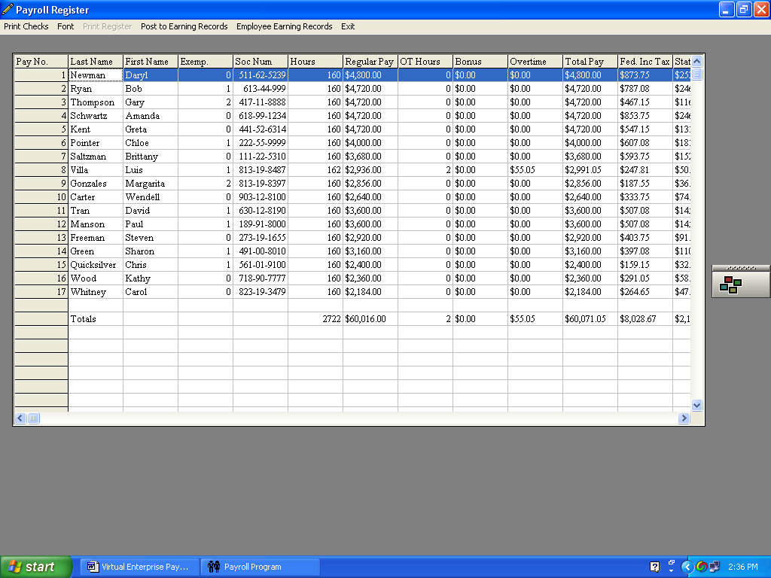
- Click Post to Earning Records on the menu bar
- Data from the payroll register for Daryl Newman should appear on the Month 1 line on the employee earning record. Next month when posting, the payroll data will appear on Month 2 line.
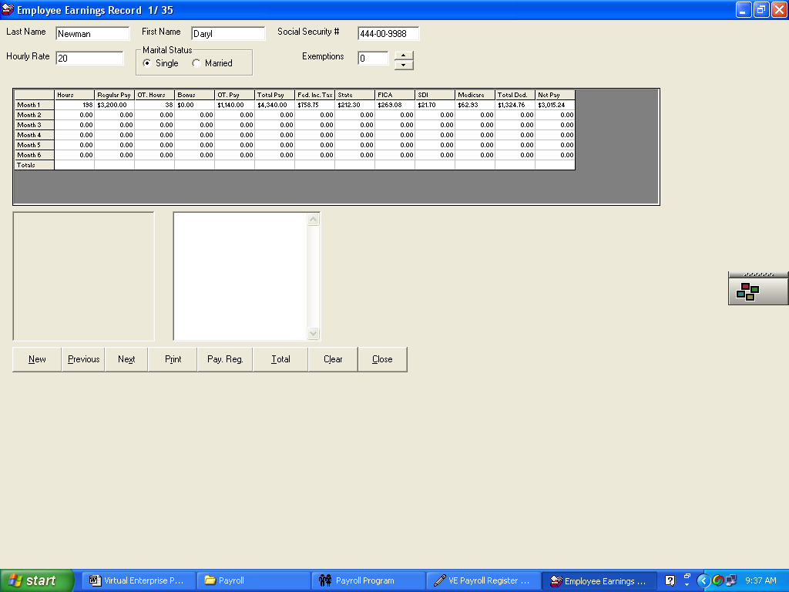
- If this is not Daryl’s earning record that was posted, then double click on Month 1 line to erase the data. Click Previous command button until you get to his record. Click Payroll Reg. button and repeat steps 2-4. Remember, the employee earning record on the screen is the one that will be posted.

- Click Next to save the record and advance to the next employee
- Click Pay Reg. command button to continue posting. The payroll register should come back into view
- Click Pay No 2 Row for Bob Ryan. The row should become highlighted
- Click Post to employee earning record

- Click Next
- Click Pay Reg,
- Repeat these steps for all 17 employees
- When finished, click Close
- File
- Exit the program
- Back up your employee earning file to a floppy, another folder or flash drive.
You may go back and check your work by using the Next and Previous buttons. If you make a mistake in posting, just double click on the month row on the employee earning record that needs to be corrected. The data will be erased and you can repost the record.
The Clear button will erase the whole bottom half of the record. Each payroll then could then be reposted to the earning record.

You may print out each employee earning record by using the Print Command button. Use the Next command button to go to the next one, and then press Print again.

Exercise 7: Printing paychecks
- Open both files: the monthly payroll file and the employee earnings file. Remember always use the same employee earning file. Only the monthly payroll file changes.
- Click Options on the menu bar
- Click Payroll Register option
- Click on Print Checks
- The first check should appear on your screen
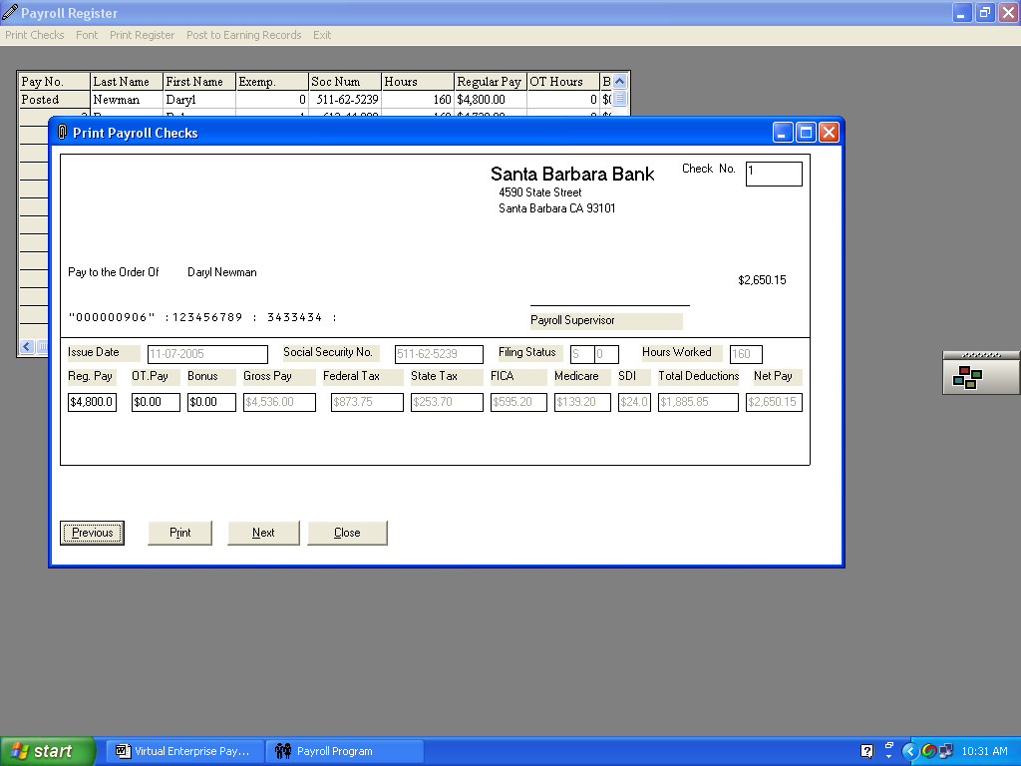
- Click on the Print command key, located at the bottom of the check
- Click the Next command key, located at the bottom of the check. The next paycheck will appear
- Click Print again for the next check
- Continue in this fashion printing checks for each employee
- Click the Close command key when finished
Note checks can be printed on just regular paper or you can purchase check forms from and office supply store.
Exercise 8: Payroll Taxes
- Select both files, if necessary
- Select Options
- Make sure that you have just recently displayed the payroll register. The taxes section needs information form this form. The menu option for Taxes will be grayed out until you display the payroll register.
- Click on Payroll taxes. Your screen should look like the one below.
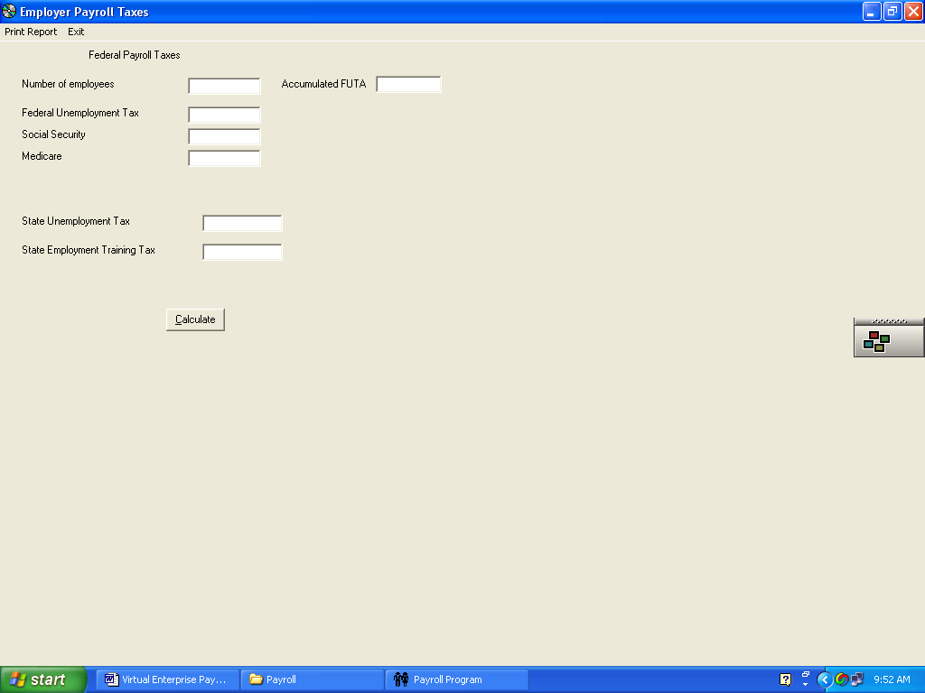
- Enter the number of employees in your company. In our simulation it is 17.
- Enter 0 in the Accumulated FUTA box, since this is our first payroll of the year
- Next month you will enter the total that appears in the Federal Unemployment Tax box here. FUTA is on the first $7,000 of an employees’ wages. That figures out to $56 for each employee. After that there is no more tax that needs to be paid for the employer
- Select Print Report
- Exit

Exercise 9: August’s Payroll
Use the following information to prepare the payroll for August
Rec No First name Last name Hours worked Bonus
1 Daryl Newman 163 100
2 Bob Ryan 159 100
3 Gary Thompson 161 100
4 Amanda Schwartz 160 100
5 Greta Kent 160 100
6 Chloe Pointer 163 0
7 Brittany Saltzman 160 0
8 Luis Villa 163 350
9 Margarita Gonzales 160 250
10 Wendell Carter 158 175
11 David Tran 162 0
12 Paul Manson 160 0
13 Steven Freeman 160 0
14 Sharon Green 165 0
15 Chris Quicksilver 160 0
16 Kathy Wood 163 0
17 Carol Whitney 160 0
Turn into your instructor the following items
Printout the payroll register. Remember to set a small font so it will all print out on one sheet. Printout each employee record.
Back up your files to another folder, flash drive or floppy.
Exercise 10: Your own payroll
- Make sure that you create your own files for your company after completing the simulation. Remember you will have one employee earning records file and six monthly payroll files. Create a new company file with your company’s information. DO BACK Up each file after you are finished with it. If you lose these files, they will have to be recreated.
- If you need to add a new employee, do so by adding them to the employee earning records file. Do this before creating the next monthly payroll file.
- To give a person a raise or demotion in salary, go into the employee earning records file and change the data. Do this before processing the next monthly payroll file.
- If a person is no longer in the class or gets fired, leave them in the employee earning records file. Just make a note in the box that they are no longer employed and give them zero hours for the remaining pay periods. They will still remain in the payroll register and employee earning records files. You still need to keep track of them even if they are no longer employed.
5. Remember if you are using Windows XP and do not have administrative privileges, you must save your files in a non-program folder.

